E-Learning Website

## ‘COSMOSCOPE’

**Report**

OF PHASE II PROJECT

**MASTER OF COMPUTER APPLICATIONS**

**(4th Semester)**

SUBMITTED BY

**MOAHAMMAD SAIF**

Batch Year– 2023-2025

Enrollment no. - U2349013

## PROJECT GUIDE - Dr. FARHA

## uoa.png

**Centre of Computer Education & Training**

**Institute of Professional Studies**

**University of Allahabad, Prayagraj**

**Uttar Pradesh – 211002**

## ****Acknowledgment****

I would like to take this opportunity to express my gratitude to everyone who has supported me in completing this project report. The completion of this project is no doubt a product of invaluable support and the contribution of the number of people.

I would like to express our sincere gratitude to **Professor Ashish Khare**, the Co-ordinator of the **Centre of Computer Education and Training** at the **University of Allahabad.**

Foremost, I would like to thank my project supervisor Dr. Farha (Centre of Computer Education and Training, Institute of Professional Studies, University of Allahabad) for their continuous help and valuable suggestions and providing encouraging environment, without which our project and this documentation would not have been possible.

I am also grateful to my family and friends for their constant support and motivation, which has kept me going throughout the project. Their belief in me and my abilities has been a source of inspiration and encouragement.

## Date: -04-25 Moahammad Saif

**Place:** IPS, UoA, Prayagraj (Enrollment No. – U2349013)

## ****Declaration****

I, Moahammad Saif, hereby declare that the project report titled "**E-Learning Website (COSMOSCOPE)**", submitted for the **Master of Computer Applications (MCA)** program at the **Centre of Computer Education & Training, University of Allahabad**, is the result of my independent work. The project has been carried out under the supervision of Dr. Farha and has not been submitted to any other institution for any other degree, diploma, or qualification.

This report is a true representation of the research, design, and development work I conducted as part of this project. I confirm that all external sources and references used in this project have been properly cited, and the project is free from plagiarism. The project content reflects my understanding and application of web technologies to create a functional e-learning platform.

## Date: -04-25 Moahammad Saif

**Place:** IPS, UoA, Prayagraj (Enrollment No. – U2349013)

**Certificate**

This is to certify that **Moahammad Saif**, student of the **Master of Computer Application (Semester – 4th)** of the Centre of Computer Education and Training, Institute of Professional Studies, University of Allahabad has completed his work in the project entitled **“E-Learning Website (COSMOSCOPE)”** under my guidance in the academic session (2024-25).

He has been taken proper care and shown utmost sincerity in completion of this project. I certify that his work in this project as per the guidelines. This project is original and is never submitted somewhere else for this same purpose.

## Date: -04-25 Dr. Farha

**Place:** IPS, UoA, Prayagraj (Project Supervisor)

**Table of Contents**

|  |  |  |
| --- | --- | --- |
| **Sr. No.** | **CONTENTS** | **Page No.** |
|  | ACKNOWLEDGEMENT | (i) |
|  | DECLARATION | (ii) |
|  | CERTIFICATE | (iii) |
|  | SYNOPSIS | (iv) |
|  | INTRODUCTION | 1-3 |
|  | 1.1 Problem Definition |  |
|  | 1.2 Motivations |  |
|  | OBJECTIVE | 4 |
|  | REQUIREMENT ANALYSIS AND SPECIFICATIONS | 5-6 |
|  | 3.1 Interface Requirements Document |  |
|  | 3.2 Software & Hardware Requirements |  |
|  | SYSTEM DESIGN | 7-9 |
|  | 4.1 DFD(Data Flow Diagram) |  |
|  | DEVELOPMENT & TESTING | 10 |
|  | MODULES | 11 |
|  | PROJECT OUTPUT | 12-19 |
|  | CODE | 20-95 |
|  | CONCLUSION | 96 |
|  | FUTURE SCOPE | 97 |
|  | MILESTONES | 98 |
|  | MEETINGS WITH THE SUPERVISOR | 99 |
|  | BIBLIOGRAPHY & REFERENCES | 100 |
|  | PLAGIARISM REPORT | 101 |

SYNOPSIS

**Table of Contents**

|  |  |  |
| --- | --- | --- |
| **Sr. No.** | **Contents** | **Page no** |
|  | Introduction | i-Iii |
|  | * 1. Problem Definition   2. Motivations |  |
|  | Objective | Iv |
|  | Requirement Analysis And Specifications | v-Vi |
|  | * 1. Interface Requirements Document   2. Software & Hardware Requirements |  |
|  | System Design | Vii-Ix |
|  | * 1. Dfd (Data Flow Diagram) |  |
|  | Development & Testing | x |
|  | Milestones | Xi |
|  | Meetings With The Supervisor | Xii |
|  | Bibliography & References | Xiii |
|  |  |  |
|  |  |  |
|  |  |  |

1. **INTRODUCTION**

**COSMOSCOPE** will be an innovative e-learning platform designed to enhance the study of **cosmology**. Cosmology, the study of the universe's origin, evolution, and eventual fate, is a field that has captivated human curiosity for centuries. Traditional educational resources, such as textbooks and lectures, often struggle to convey the dynamic and vast nature of the universe in an engaging manner. These methods may lack the interactivity and visual appeal needed to fully capture the imagination and interest of learners.

**COSMOSCOPE** will be conceived as a solution to these challenges. By harnessing modern web technologies, this project will aim to create an educational platform that will not only provide comprehensive information on cosmology but also engage users through interactive and immersive content. The core feature of the website will be a **3D animated milky way galaxy**, allowing users to explore the planets and other celestial bodies in an interactive manner.

In addition to the 3D model, **COSMOSCOPE** will offer a wealth of educational resources, including **mission, news**, **quiz game**, **AI powered virtual assistant and an e-commerce section for space-themed products**. The content will cover a wide range of topics, from the basic principles of cosmology to the latest discoveries and theories in the field.

**Title of the Project** - E-learning website (COSMOSCOPE)  
**Category** - Web Development

**1.1 PROBLEM DEFINITION**

Cosmology, a field that explores the origin, structure, evolution, and eventual fate of the universe, presents complex and dynamic concepts that are difficult to convey through traditional educational resources. Existing resources such as textbooks and static websites have several limitations:

* **Lack of Interactivity:** Traditional resources often fail to provide an engaging learning experience. Static text and images cannot effectively demonstrate the dynamic nature of astronomical phenomena.
* **Limited Engagement:** Without interactive elements, learners may find it challenging to stay interested and motivated, leading to a superficial understanding of the material.
* **Accessibility Issues:** Many educational materials are not easily accessible to all learners, particularly those with different learning styles or those who require more visual and interactive content.
* **Outdated Information:** Cosmology is a rapidly advancing field. Traditional resources may not always reflect the latest discoveries and developments, leaving learners with outdated information.
* **Lack of Personalization:** Traditional educational approaches do not cater to individual learning paces and preferences. There is a need for personalized learning experiences that adapt to the unique needs of each learner.

**MOTIVATIONS**

The motivation behind Cosmoscope is to create a comprehensive educational platform that addresses these challenges by providing:

* **Enhanced Engagement:** Utilizing interactive 3D models and animations to make learning more engaging and enjoyable.
* **Improved Understanding:** Simplifying complex concepts through visual aids, interactive tutorials, and simulations, making them easier to grasp.
* **Promotion of Lifelong Learning:** Encouraging sustained interest in cosmology by offering a platform that is both educational and enjoyable.
* **Accessibility and Inclusivity:** Making cosmological education accessible to a broader audience, including those with diverse learning styles and backgrounds.
* **Up-to-Date Information:** Providing users with the latest updates and developments in cosmology to ensure they are always informed.
* **Personalized Learning Experiences:** Offering features such as user profiles, progress tracking, and tailored content to meet individual learning needs.
* **Inspiring Future Scientists:** Sparking curiosity and passion for astronomy, potentially inspiring users to pursue further studies or careers in the field.

**OBJECTIVE**

To enhance the Cosmoscope platform by integrating advanced interactive features, including a 3D model of the Milky Way galaxy, an AI-powered chatbot for cosmology-related inquiries, a quiz-based learning module to engage users, and an e-commerce section for space-themed products. These improvements aim to provide a more immersive, educational, and interactive experience, fostering curiosity and deeper learning in space science.

**REQUIREMENT ANALYSIS AND SPECIFICATIONS**

* 1. **Functional Requirements**

1. **User/admin Authentication:**

* Registration
* Login/Logout
* Password recovery

1. **3D Animated Solar System:**

* Interactive 3D model
* Detailed information about planets and celestial bodies

1. **Educational Content:**

* Enhanced news section
* Enhanced mission section
* Interactive quiz game

1. **AI Powered Virtual Assistance:**

* **Answer questions about cosmology topics**

1. **Interactive Quiz Game:**

* Multiple-choice questions
* Leader boards to rank users based on their score
* Feedback after each question and detailed explanations

1. **E-commerce:**

* An e-commerce section for space-themed products.

**SOFTWARE AND HARDWARE REQUIREMENTS**

## Minimum Software Requirements

* **Operating System:** Windows 10/MacOS/Linux
* **Web Browser:** Google Chrome, Mozilla Firefox, Safari
* **Programming Languages:** HTML, CSS, JavaScript,
* **Database:** MySQL
* **Version Control:** Git
* **IDE:** Visual Studio Code, PyCharm

## Minimum Hardware Requirements

* **Processor:** Intel Core i5 or equivalent
* **RAM:** 8GB minimum
* **Storage:** 500GB HDD or SSD
* **Graphics Card:** NVIDIA GeForce GTX 1050 or equivalent
* **Internet Connection:** Broadband connection with 10 Mbps speed

1. **DATA FLOW DIAGRAM**

**Level - 0**

Cosmoscope

Login

Logout

Add program & module

Logout

User Report

Login

3D tutorial

User

User Registration

Admin

Context Level DFD for Cosmoscope   
  
  
  
  
  
  
  
  
  
  
  
  
  
  
  
 **Level -1**

Dashboard

Manage  
 e-commerce

Manage contents

Manage user’s permission

Manage AI virtual assistant

Manage Quiz game

Manage feedback

Manage news updates

Manage user details

Module’s Management

Database

Login

Send Email/SMS to user

Forgot Password

Admin

**Level -2**

User DB

User reports

User Registration

User details

Game DB

Quiz game

Upload game

Play game

Upload Latest News

User

Read news

Read mission

Module DB

Cosmoscope module

Admin

Add module

Virtual Assistant

Mission module

Upload mission

Tutorial DB

**DEVELOPMENT AND TESTING**

**Development:**

* Implement additional backend functionalities using Node.js.
* Develop a 3D model of the Milky Way galaxy.
* Integrate an AI chatbot for answering cosmology-related questions.
* Create a quiz game for interactive learning.
* Develop an e-commerce platform for cosmology-related products.
* Enhance user authentication and data management systems.

**Testing:**

1. **Content Accuracy and Quality:** Ensure explanations of complex concepts are understandable. Check that images, diagrams, and videos are high-quality and correctly labeled.
2. **Links and Buttons**: Verify that all hyperlinks, buttons, and interactive elements work correctly.
3. **Visuals**: Check that images, diagrams, and videos are high-quality and correctly labeled.
4. **Readability**: Check that text is easy to read, with appropriate fonts, sizes, and contrast.
5. **Load Times**: Check that pages load quickly. Optimize images and scripts if necessary.
6. **Mobile Responsiveness**: Ensure the site is fully functional and visually appealing on mobile devices and tablets.
7. **MILESTONES**

|  |  |  |  |
| --- | --- | --- | --- |
| **Sr. No** | **Project activity** | **Estimated Start Date** | **Estimated End Date** |
|  | Project allotment | 02/01/25 | 13/01/25 |
|  | Synopsis creation | 20/01/25 | 24/01/25 |
|  | Implementation start | 25/01/25 | 13/03/25 |
| 4 | Created quiz game | 26/01/25 | 29/01/25 |
|  | Update 3D solar system | 29/01/25 | 30/01/25 |
|  | Studied about how to maintain a database of frontend. | 31/01/25 | 31/01/25 |
|  | Update admin panel | 01/02/25 | 15/02/25 |
|  | Created AI powered virtual assistant | 15/02/25 | 05/03/25 |
|  | Created leader board page | 05/03/25 | 10/03/25 |
|  | Testing each and every modules of the project. | 10/03/25 | 13/03/25 |

1. **MEETINGS WITH THE SUPERVISOR**

|  |  |  |  |
| --- | --- | --- | --- |
| **Date of the meet** | **Mode** | **Comments by the supervisor** | **Signature of the supervisor** |
| 10/01/25 | Offline | Details description about project topic. |  |
| 23/01/25 | Offline | Feedback on the synopsis |  |
| 24/01/25 | Offline | Final synopsis review |  |

**BIBLIOGRAPHY AND REFERENCES**

**[1] Jayant V. Narlikar*.* (1996):** Introduction to Cosmology*.* Cambridge University Press.

**[2] Tarun Kumar Das.(2015):** Cosmology and Astrophysics through Problems*.* Cambridge University Press.

**[3] Andrews, J. D. W. (1984):** Discovery and Expository Learning Compared: Their  
Effects on Independent and Dependent Students. The Journal of Educational Research, 78(2), 80–89.

**[4] Balım, A. G. (2009):** The Effects of Discovery Learning on Students’ Success and Inquiry Learning Skills. Eurasian Journal of Educational Research (EJER), (35), 1-20.

**[5] Baharudin, R., & Luster, T. (1998):** Factors related to the quality of the home environment and children’s achievement. Journal of Family Issues, 19(4), 375-403

**PROJECT REPORT**

**INTRODUCTION**

**COSMOSCOPE** is an innovative e-learning platform designed to enhance the study of cosmology. Cosmology, the study of the universe's origin, evolution, and eventual fate, is a field that has captivated human curiosity for centuries. Traditional educational resources, such as textbooks and lectures, have often struggled to convey the dynamic and vast nature of the universe in an engaging manner. These methods have sometimes lacked the interactivity and visual appeal needed to fully capture the imagination and interest of learners, especially when dealing with complex topics.

**COSMOSCOPE** has been conceived as a solution to these challenges. By harnessing modern web technologies, this project has aimed to create an educational platform that not only provides comprehensive information on cosmology but also engages users through interactive and immersive content. The core feature of the website has become a 3D animated mily way galaxy, which allows users to explore the planets and other celestial bodies in an interactive manner.

In addition to the 3D model, COSMOSCOPE has evolved into a comprehensive educational and interactive platform. It now offers a wealth of features including a quiz game, a virtual AI assistant, real-time space-related news, and detailed information on ongoing and past space missions. To further enhance user engagement and outreach, an integrated e-commerce website has been added, offering space-themed products and learning kits. The educational content spans from fundamental cosmological principles to the most recent discoveries and theories in the field, making COSMOSCOPE a central hub for space enthusiasts and learners alike

**Title of the Project:** E-learning website (COSMOSCOPE)  
**Category:** Web Development

**PROBLEM DEFINITION**

Cosmology, a field that explores the origin, structure, evolution, and eventual fate of the universe, presents complex and dynamic concepts that are difficult to convey through traditional educational resources. Existing resources such as textbooks and static websites have several limitations:

* **Lack of Interactivity:** Traditional resources often fail to provide an engaging learning experience. Static text and images cannot effectively demonstrate the dynamic nature of astronomical phenomena.
* **Limited Engagement:** Without interactive elements, learners may find it challenging to stay interested and motivated, leading to a superficial understanding of the material.
* **Accessibility Issues:** Many educational materials are not easily accessible to all learners, particularly those with different learning styles or those who require more visual and interactive content.
* **Outdated Information:** Cosmology is a rapidly advancing field. Traditional resources may not always reflect the latest discoveries and developments, leaving learners with outdated information.
* **Lack of Personalization:** Traditional educational approaches do not cater to individual learning paces and preferences. There is a need for personalized learning experiences that adapt to the unique needs of each learner.

**MOTIVATIONS**

The motivation behind the development of COSMOSCOPE has been to create a comprehensive and engaging educational platform that addresses the limitations of traditional cosmology education. This project has aimed to revolutionize how cosmology is taught by offering features that enhance the learning experience:

* **Enhanced Engagement:** COSMOSCOPE has utilized interactive 3D models and animations to make the learning process more engaging and enjoyable. These interactive elements have brought cosmic phenomena to life, making it easier for learners to visualize complex concepts.
* **Improved Understanding:** By incorporating visual aids, interactive tutorials, and simulations, COSMOSCOPE has simplified intricate cosmological theories. This approach has helped learners grasp challenging topics, such as black holes, dark matter, and planetary orbits, with greater ease.
* **Promotion of Lifelong Learning:** The platform has encouraged a sustained interest in cosmology by providing content that is both educational and enjoyable. COSMOSCOPE has been designed not just as a one-time learning tool but as a resource that inspires continuous exploration and curiosity about the universe..
* **Up-to-Date Information:** Cosmology is an ever-evolving field, and COSMOSCOPE has ensured that users have access to the latest research and discoveries. The platform has integrated real-time updates on cosmological advancements, helping learners stay informed and connected to cutting-edge developments.
* **Inspiring Future Scientists:** One of the core motivations of COSMOSCOPE has been to spark a passion for cosmology and astronomy among learners. By offering an immersive, engaging platform, COSMOSCOPE has aimed to inspire future scientists, encouraging users to pursue further studies or careers in astronomy and cosmology.

**OBJECTIVE**

To enhance the Cosmoscope platform by integrating advanced interactive features, including a 3D model of the Milky Way galaxy, an AI-powered chatbot for cosmology-related inquiries, a quiz-based learning module to engage users, and an e-commerce section for space-themed products. These improvements aim to provide a more immersive, educational, and interactive experience, fostering curiosity and deeper learning in space science.

**REQUIREMENT ANALYSIS AND SPECIFICATIONS**

* 1. **Functional Requirements**

1. **User/admin Authentication:**

* Registration
* Login/Logout
* Password recovery

1. **3D Animated Solar System:**

* Interactive 3D model
* Detailed information about planets and celestial bodies

1. **Educational Content:**

* Enhanced news section
* Enhanced mission section
* Interactive quiz game

1. **AI Powered Virtual Assistance:**

* **Answer questions about cosmology topics**

1. **Interactive Quiz Game:**

* Multiple-choice questions
* Leader boards to rank users based on their score
* Feedback after each question and detailed explanations

1. **E-commerce:**

* An e-commerce section for space-themed products.

**SOFTWARE AND HARDWARE REQUIREMENTS**

## Minimum Software Requirements

* **Operating System:** Windows 10/MacOS/Linux
* **Web Browser:** Google Chrome, Mozilla Firefox, Safari
* **Frontend Language:** HTML, CSS, JavaScript, Three.js
* **Backend Language:** Node.js
* **Database:** MySQL
* **Version Control:** Git
* **IDE:** Visual Studio Code, PyCharm

## Minimum Hardware Requirements

* **Processor:** Intel Core i5 or equivalent
* **RAM:** 8GB minimum
* **Storage:** 500GB HDD or SSD
* **Graphics Card:** NVIDIA GeForce GTX 1050 or equivalent
* **Internet Connection:** Broadband connection with 10 Mbps speed

**DATA FLOW DIAGRAM**

Add program & module

Logout

User Report

Login

Login

Logout

Video tutorial

Cosmoscope

User

User Registration

Admin

Context Level DFD for E-Learning System

# Level -1

Modules Management

Manage user details

Manage news updates

Manage feedback

Manage quotes

Manage contents

Manage user’s permission

Dashboard

Database

Login

Send Email

/SMS to user

Forgot

Password

Admin

**Level -2**

User DB

User reports

User Registration

User details

Upload Latest News

Read news

User

Module DB

Admin

Read mission

Cosmoscope module

Add module

Mission module

Upload mission

Tutorial DB

**DEVELOPMENT AND TESTING**

**Development:**

* Implement additional backend functionalities using Node.js.
* Develop a 3D model of the Milky Way galaxy.
* Integrate an AI chatbot for answering cosmology-related questions.
* Create a quiz game for interactive learning.
* Develop an e-commerce platform for cosmology-related products.
* Enhance user authentication and data management systems.

**Testing:**

1. **Content Accuracy and Quality:** Ensure explanations of complex concepts are understandable. Check that images, diagrams, and videos are high-quality and correctly labeled.
2. **Links and Buttons**: Verify that all hyperlinks, buttons, and interactive elements work correctly.
3. **Visuals**: Check that images, diagrams, and videos are high-quality and correctly labeled.
4. **Readability**: Check that text is easy to read, with appropriate fonts, sizes, and contrast.
5. **Load Times**: Check that pages load quickly. Optimize images and scripts if necessary.
6. **Mobile Responsiveness**: Ensure the site is fully functional and visually appealing on mobile devices and tablets.

**MODULES**

**COSMOSCOPE** has comprised several modules that contribute to its functionality and user experience. Each module has been developed to provide information on different aspects of cosmology and to enhance the user’s learning journey.

* **Home Module:** The landing page has offered a brief introduction to the COSMOSCOPE platform, inviting users to explore the universe. This module has provided quick navigation to the main features, 3D animated milky way galaxy, news, and more.
* **3D Milky Way Galaxy Module:** This interactive module has allowed users to explore a 3D model of the milky ways galaxy, with zoom and rotation functionalities. Users have been able to learn about each planet, including details such as distances, composition, and unique characteristics.
* **Mission Explorer Module:** This module has provided information on ISRO’s major space missions. Each mission has included details like the launch date, objectives, outcomes, and scientific significance, giving users insights into India's contributions to space exploration.
* **News Module:** This module contains the latest news on astronomy. Users have received real-time updates to stay informed on recent advancements in space research.
* **Quote Module:** This module has displayed inspiring quotes about space, science, and exploration, enhancing the educational atmosphere and motivating users.
* **User Authentication Module:** This module has provided secure login and registration options, allowing users to create accounts, save progress, and personalize their experience on COSMOSCOPE.
* **Admin Panel Module:** The admin panel has enabled administrators to manage content, including news updates, quotes, and user data, ensuring the site remains relevant and secure.
* **Quiz Game Module:**  
  An engaging quiz-based learning module where users can test their knowledge on cosmology and space science through different levels and question sets, with scores and feedback.
* **Virtual AI Assistant Module:**  
  An intelligent chatbot trained to answer questions related to cosmology, astronomy, and the platform itself. It offers real-time interaction to assist learners, recommend content, and make exploration smoother.
* **E-commerce Module:**  
  A newly integrated online store offering space-themed products, educational kits, posters, books, and merchandise for enthusiasts and learners, blending education with curiosity-driven commerce.

**SCREENSHOTS OF PROJECT OUTPUT**

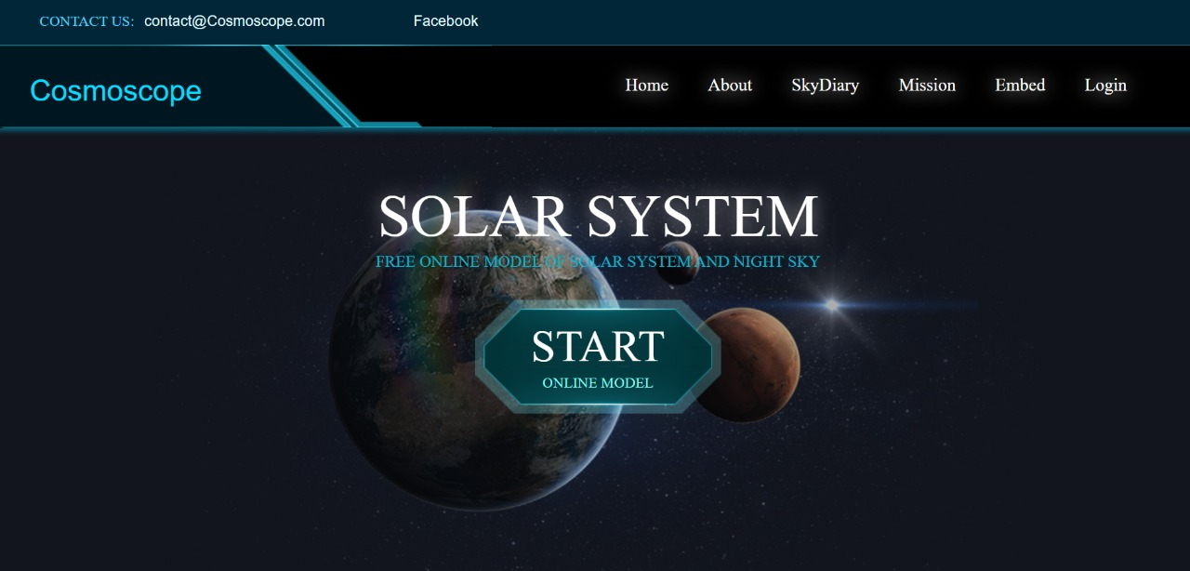

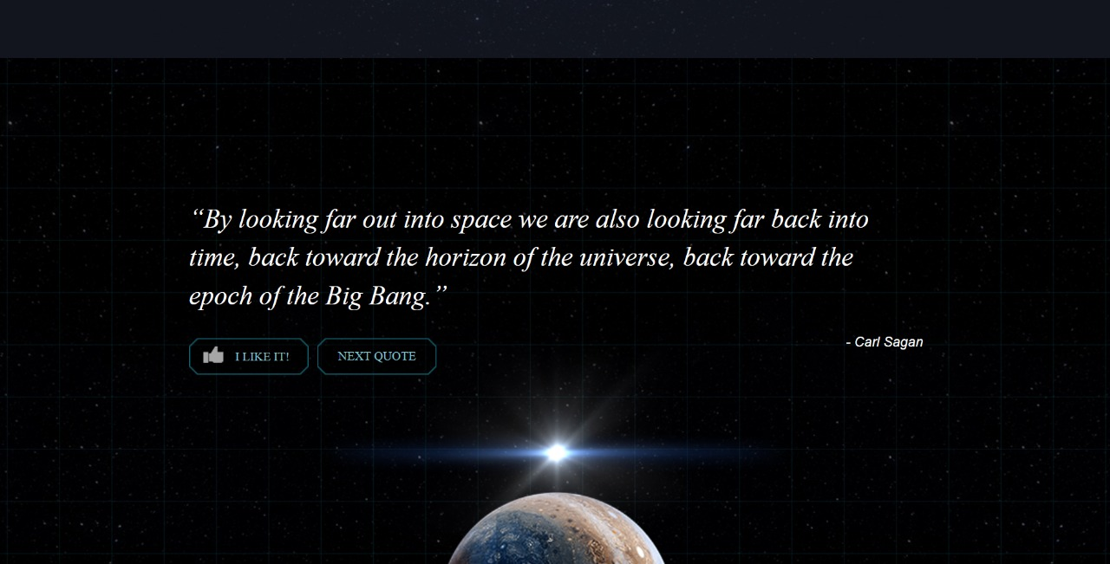

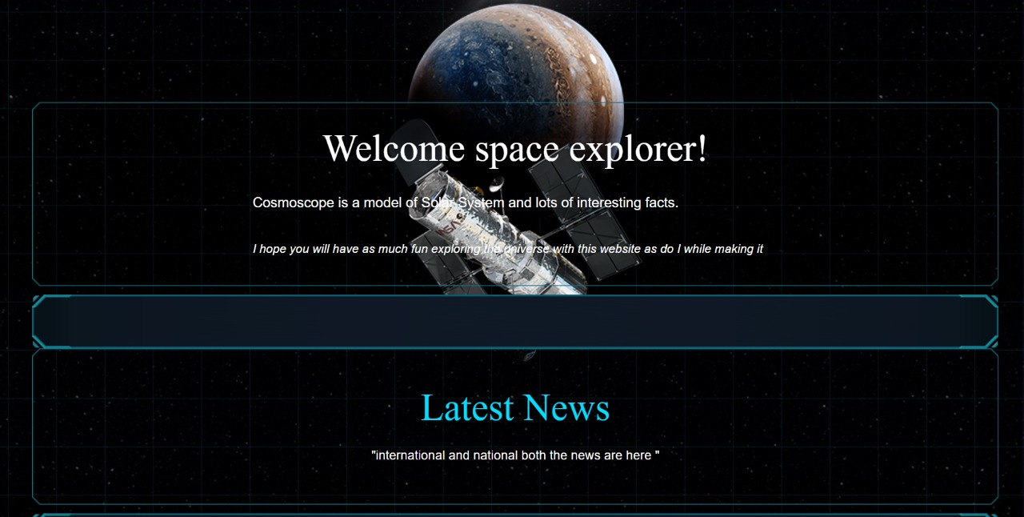

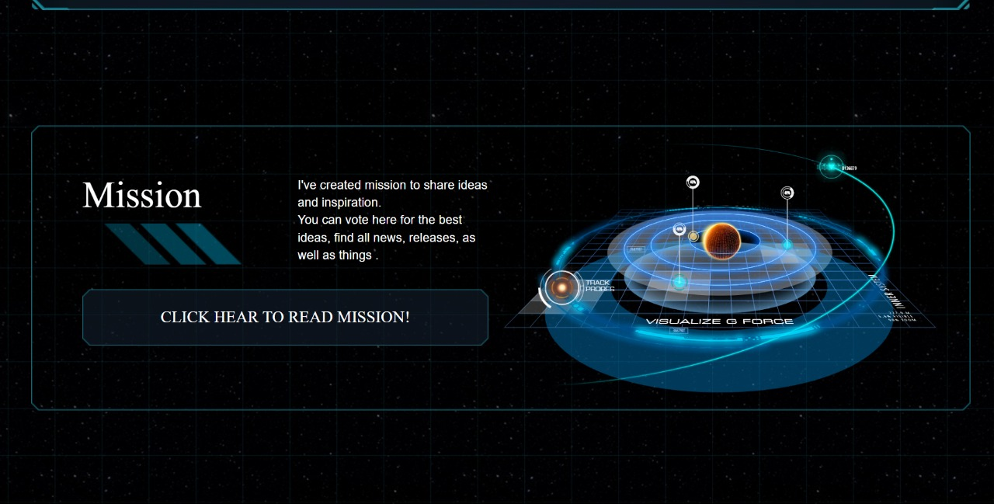

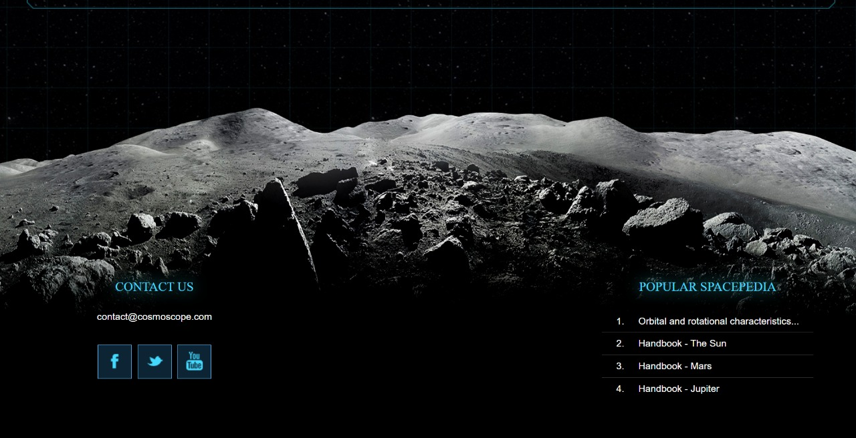

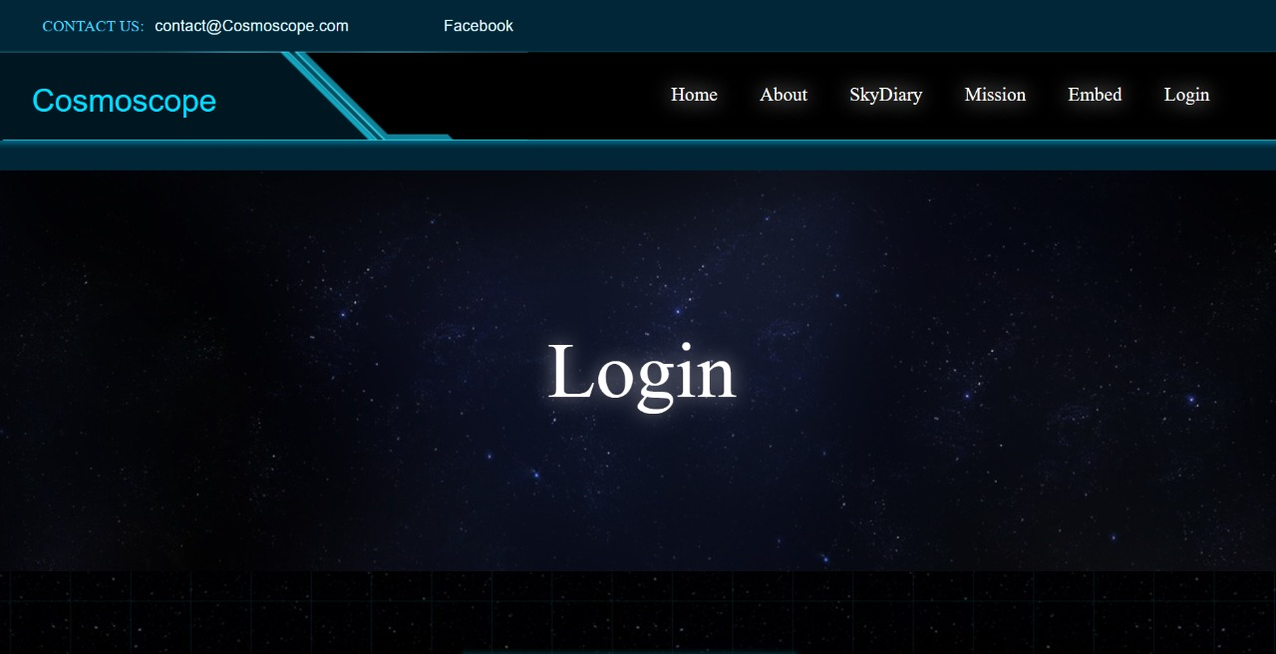

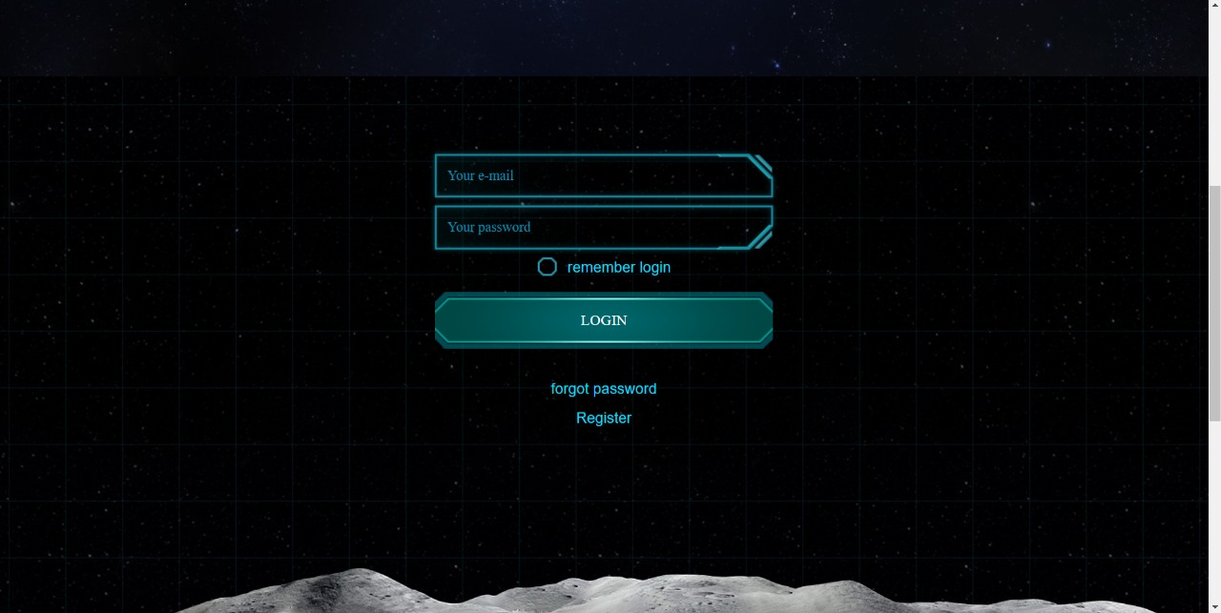

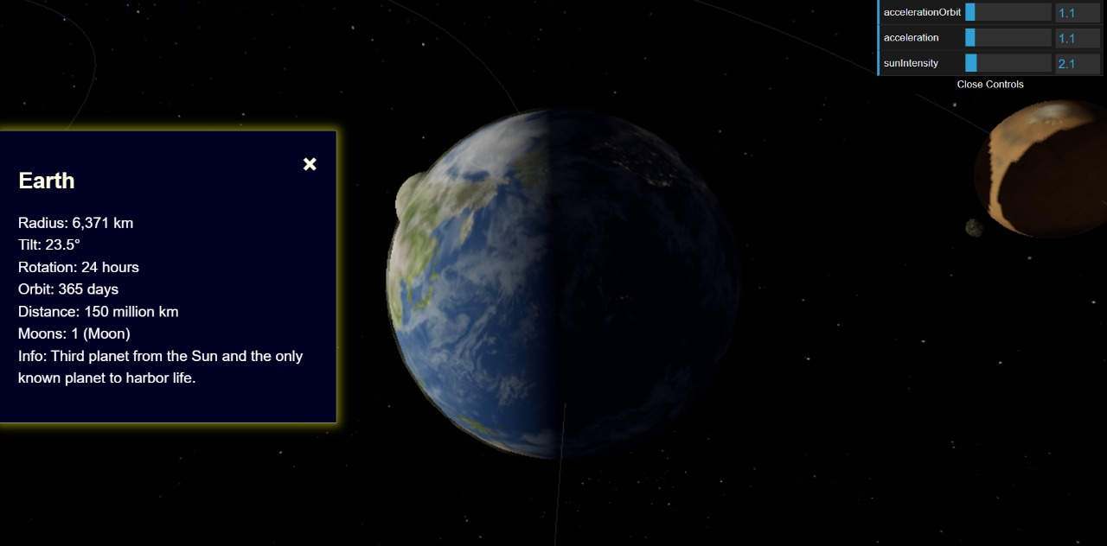

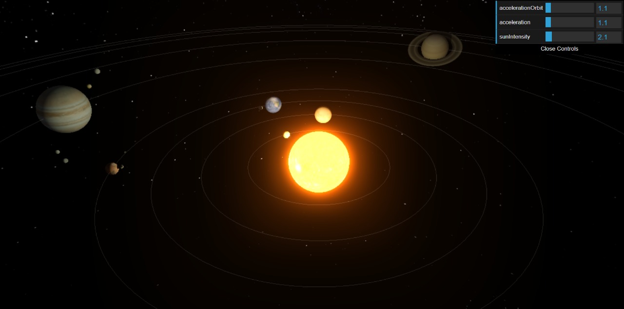

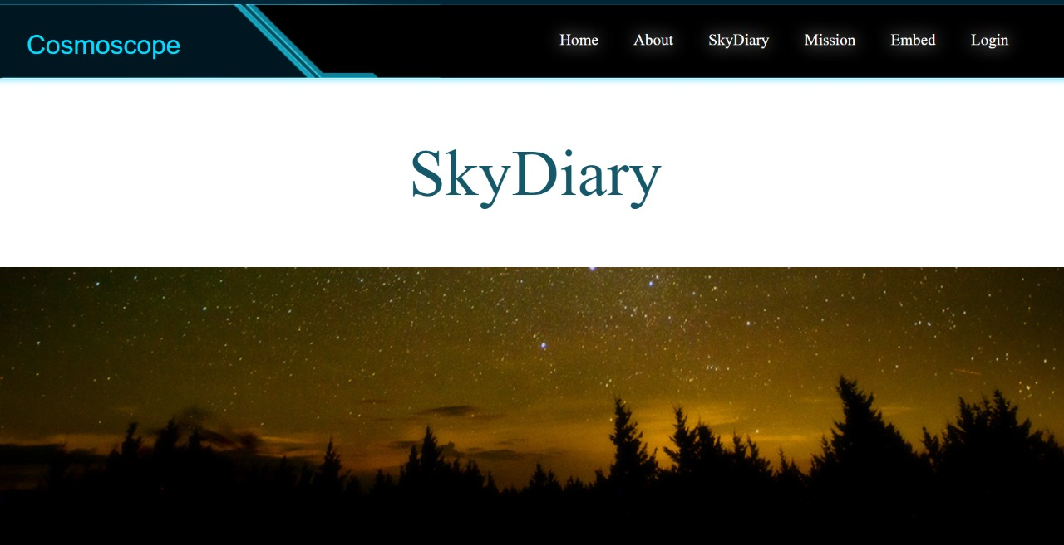

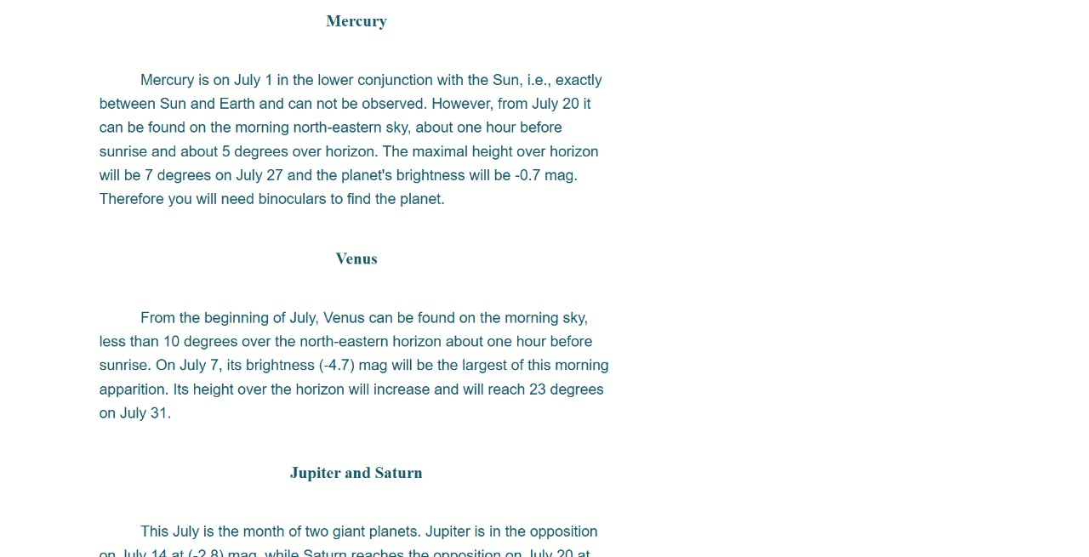

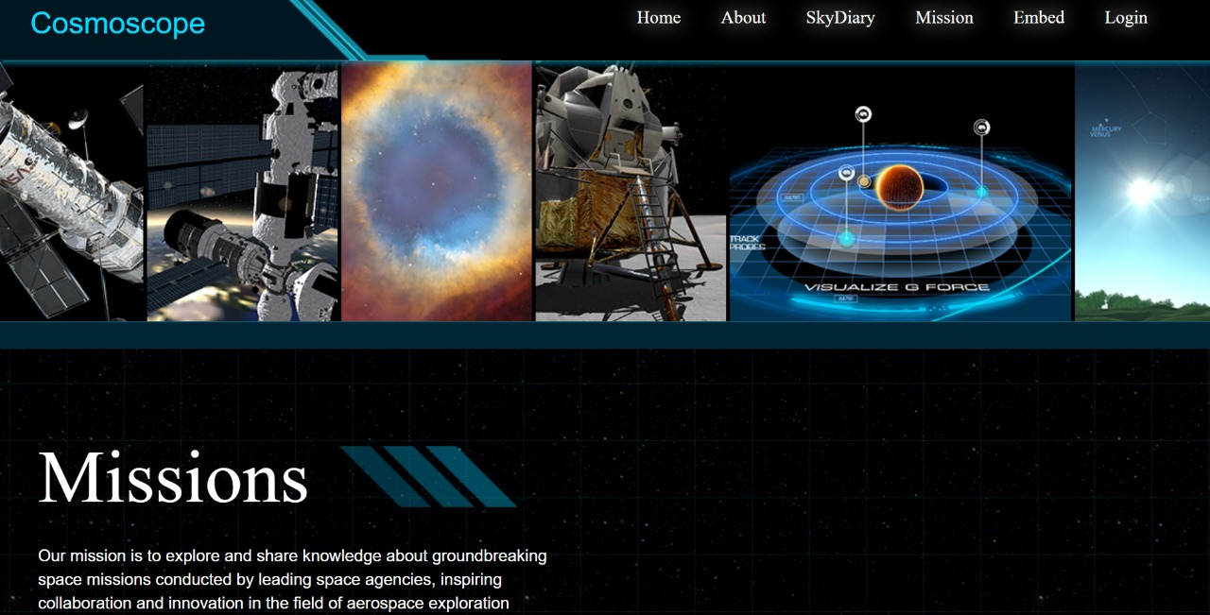

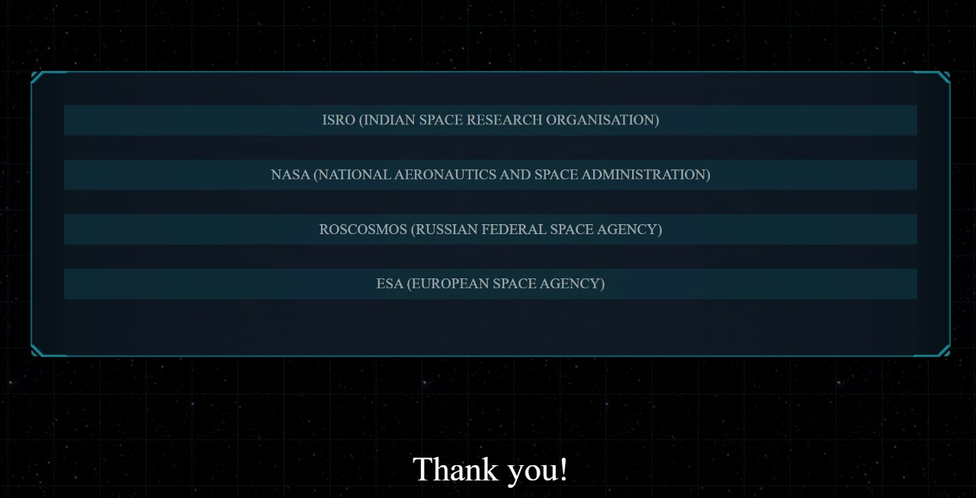

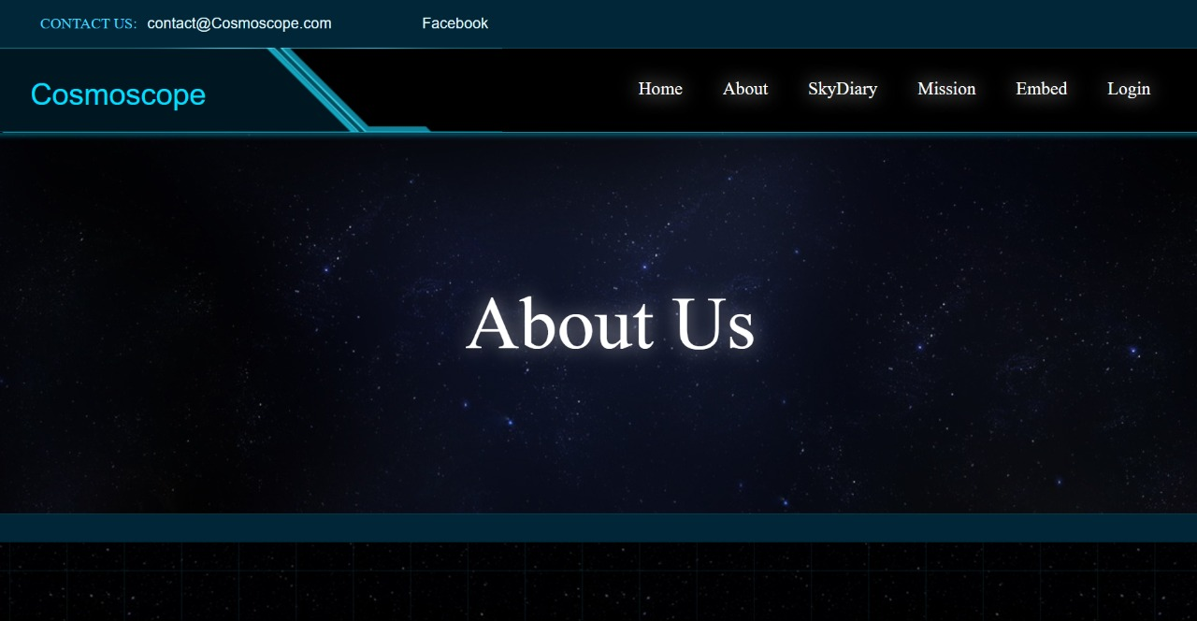

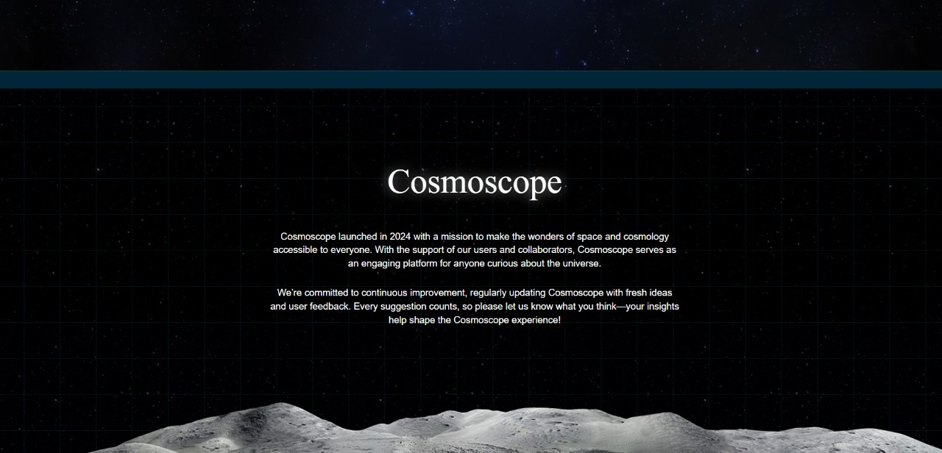

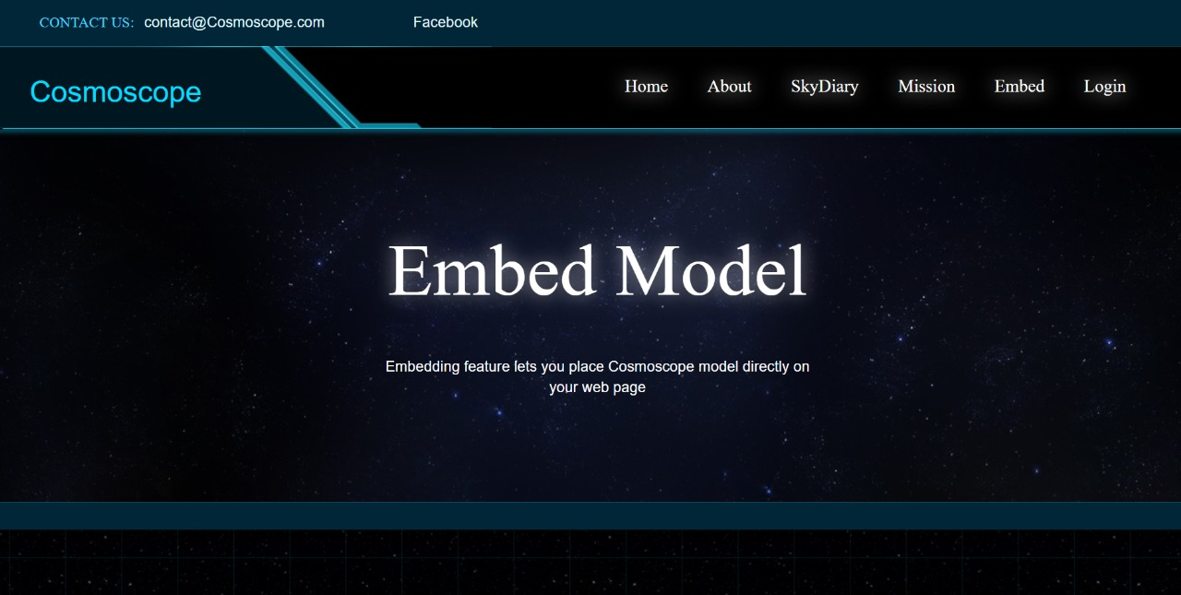

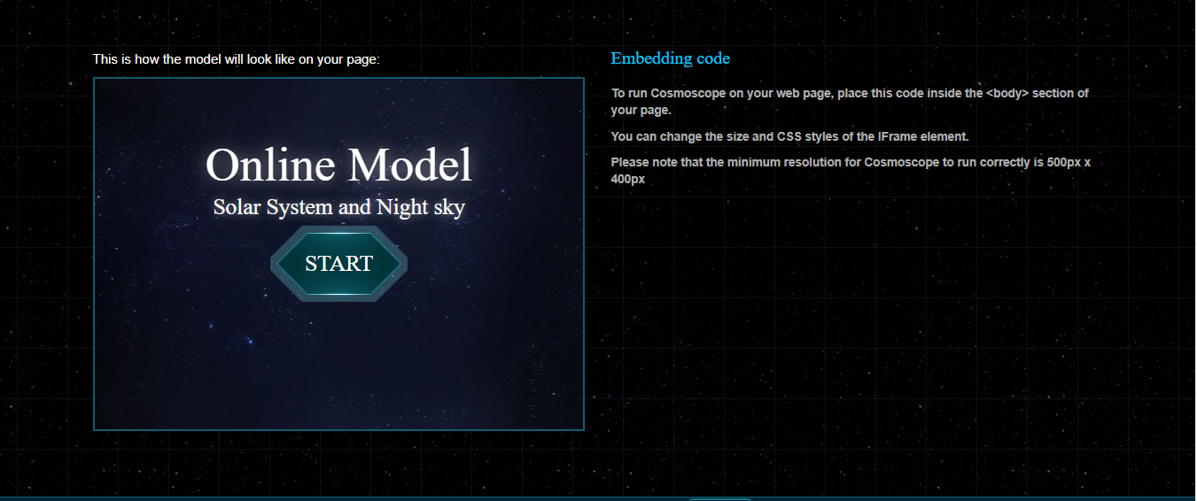

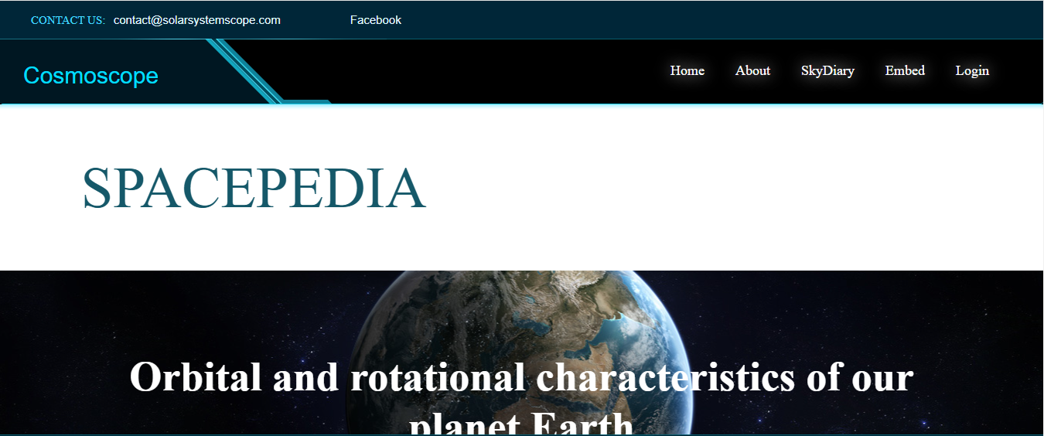

**CODE**

**Index.html**

<!DOCTYPE html>

<html lang="en">

<head>

<!-- Meta Tags for Charset, Compatibility, and Viewport -->

<meta charset="utf-8">

<meta http-equiv="X-UA-Compatible" content="IE=edge,chrome=1">

<meta name="viewport" id="viewport" content="width=device-width, initial-scale=1">

<!-- Page Title and SEO Meta Tags -->

<title>Cosmoscope - Online Model of Solar System</title>

<meta name="description" content="Online 3D simulation of the Solar System and night sky in real-time - the Sun, planets, dwarf planets, comets, stars and constellations" />

<meta name="keywords" content="solar system, planets, orbits, night sky, stars, constellations, space, universe, sun, mercury, venus, earth, mars, jupiter, saturn, uranus, neptune, pluto" />

<!-- Favicon and Social Media Image -->

<link rel="shortcut icon" href="images/favicon.png" />

<link rel="image_src" type="image/jpeg" href="images/favicon.png" />

<!-- Viewport Update Script: Adjusts for different screen orientations -->

<script>

var updateViewport = function() {

var minWidth = 500;

var screenWidth = screen.width;

switch (window.orientation) {

case -90:

case 90:

minWidth = 730;

screenWidth = screen.height;

break;

}

document.getElementById("viewport").setAttribute("content", "width=device-width, initial-scale=" + (screenWidth / minWidth));

}

window.addEventListener('orientationchange', updateViewport);

updateViewport();

</script>

<!-- Google Tag Manager Script -->

<script>

(function(w, d, s, l, i) {

w[l] = w[l] || [];

w[l].push({

'gtm.start': new Date().getTime(),

event: 'gtm.js'

});

var f = d.getElementsByTagName(s)[0],

j = d.createElement(s),

dl = l != 'dataLayer' ? '&l=' + l : '';

j.async = true;

j.src = 'https://www.googletagmanager.com/gtm.js?id=' + i + dl;

f.parentNode.insertBefore(j, f);

})(window, document, 'script', 'dataLayer', 'GTM-MDW8FQ9');

</script>

<!-- jQuery -->

<script src="https://ajax.googleapis.com/ajax/libs/jquery/3.2.1/jquery.min.js"></script>

<script type="text/javascript" src="lib/jquery.validate.min.js"></script>

<!-- Bootstrap -->

<script src="https://maxcdn.bootstrapcdn.com/bootstrap/3.3.7/js/bootstrap.min.js" integrity="sha384-Tc5IQib027qvyjSMfHjOMaLkfuWVxZxUPnCJA7l2mCWNIpG9mGCD8wGNIcPD7Txa" crossorigin="anonymous"></script>

<link rel="stylesheet" href="https://maxcdn.bootstrapcdn.com/bootstrap/3.3.7/css/bootstrap.min.css" integrity="sha384-BVYiiSIFeK1dGmJRAkycuHAHRg32OmUcww7on3RYdg4Va+PmSTsz/K68vbdEjh4u" crossorigin="anonymous">

<link rel="stylesheet" href="lib/bootstrap-xxs-tn.css">

<!-- Mobile Detect -->

<script src="lib/mobile-detect.min.js"></script>

<!-- CSS Files for Solar System Model -->

<link rel="stylesheet" href="css/fonts.css?v=2.015" />

<link rel="stylesheet" href="css/main.css?v=2.015" />

<link rel="stylesheet" href="css/ui.css?v=2.015" />

<link rel="stylesheet" href="css/header.css?v=2.015" />

<link rel="stylesheet" href="css/footer.css?v=2.015" />

<link rel="stylesheet" href="css/model-home.css?v=2.015" />

<link rel="stylesheet" href="css/home.css?v=2.015" />

<!-- JavaScript for Solar System Model -->

<script src="js/solar.js?v=2.015"></script>

<!-- Script for Menu Hover Show/Hide -->

<script>

$(document).ready(function() {

// Menu toggle functionality

var menu = $("#header .menu-hover");

var menuBtn = $("#header .menu-hover-start-button");

var menuDrop = $("#header .menu-hover-backdrop");

// Function to Hide Menu

var menuHideCheck = function(e) {

if (menu.is(":hidden")) return;

var target = $(e.target);

var modal = $(".modal");

if (menu.has(target).length || menu.is(target) || modal.has(target).length || modal.is(target)) return;

menu.slideUp();

menuDrop.fadeOut();

$(document).off("click", menuHideCheck);

setTimeout(function() {

menuBtn.on("click", menuShow);

}, 1);

}

// Function to Show Menu

var menuShow = function(e) {

if (!menu.is(":hidden")) return;

menu.slideDown();

menuDrop.fadeIn();

menuBtn.off("click", menuShow);

setTimeout(function() {

$(document).on("click", menuHideCheck);

}, 1);

}

menuBtn.on("click", menuShow);

});

</script>

</head>

<body page="home">

<!-- Google Tag Manager NoScript -->

<noscript>

<iframe src="https://www.googletagmanager.com/ns.html?id=GTM-MDW8FQ9" height="0" width="0" style="display:none;visibility:hidden"></iframe>

</noscript>

<!-- Header with Navigation and Contact Details -->

<div id="header">

<div class="first hidden-xs">

<a class="contact" href="mailto:contact@Cosmoscope.com">

<span>Contact us:</span>

<span>contact@Cosmoscope.com</span>

</a>

<a class="button facebook hidden-xs hidden-sm hidden-md" href="https://www.facebook.com/" target="_blank">Facebook</a>

</div>

<!-- Navigation Menu -->

<div class="navbar">

<div class="glow-bottom-8px"> </div>

<div class="logo-holder">

<a href="/"><h2>Cosmoscope</h2></a>

</div>

<div class="menu">

<a class="button show-on-start text-glow home selected" href="index.html">Home</a>

<a class="button show-on-start text-glow" href="about.html">About</a>

<a class="button show-on-start text-glow" href="skydiary.html">SkyDiary</a>

<a class="button show-on-start text-glow" href="lab.html">Mission</a>

<a class="button show-on-start text-glow" href="embed.html">Embed</a>

<a class="button show-on-start text-glow" href="login.html">Login</a>

<div class="divider"></div>

</div>

</div>

</div>

<!-- Menu Hover Functionality (Hidden by Default) -->

<div class="menu-hover-backdrop" style="display: none;"></div>

<div class="menu-hover" style="display: none;"></div>

<div class="solar-model">

<!-- ------------------------MODEL WINDOW DESKTOP OK------------------------- -->

<div class="solar-model-ok only-dsk">

<div class="solar-model-ok-inner" style="position: absolute; left: 0; top: 0; right: 0; bottom: 0;">

<div class="bg-image"></div>

<div class="model-header">

<div class="solar-h1">Solar System</div>

<div class="solar-h2">Free online model of Solar System and Night sky</div>

</div>

<a class="model-btn-start btn-type-8-turquoise" href="module.html">

<div class="t1">Start</div>

<div class="t2">online model</div>

</a>

</div>

</div>

<!-- ------------------------MODEL WINDOW RUNNING------------------------- -->

<div class="solar-model-run" style="display: none;">

<div id="solar-model-container" style="width: 100%; height: 100%;">

<svg id="solar-system" viewBox="0 0 800 800" style="width: 100%; height: 100%;">

<circle cx="400" cy="400" r="50" fill="yellow" id="sun" />

<circle cx="300" cy="400" r="20" fill="blue" id="earth" />

<circle cx="500" cy="400" r="15" fill="red" id="mars" />

<!-- Add more planets as needed -->

</svg>

</div>

</div>

<!-- ------------------------MODEL WINDOW MOBILE------------------------- -->

<div class="solar-model-mobile only-mbl">

<div class="bg-image"></div>

<div class="model-header">

<div class="solar-h1">Solar System</div>

<div class="solar-h2" style="margin-bottom: 40px;">Free model of Solar System and Night sky</div>

</div>

</div>

<!-- ------------------------SCRIPT FOR FUNCTIONALITY------------------------- -->

</div>

<div class="container solar-content content-home">

<div class="quote-holder">

<div class="fixed-position">

<div class="quote-box" id="5">

<div class="text"><span style="font-size:109%">“We make our world significant by the courage of our questions and the depth of our answers.”</span></div>

<div class="author">- Carl Sagan</div>

</div>

<div class="buttons">

<a class="panel-type-10-semi-black-bg like"><span class="like-text">i like it!</span><span class="like-count">12061</span></a>

<a class="panel-type-10-semi-black-bg next">next quote</a>

</div>

</div>

<script>

var quotes = [{

id: 5,

text: "We make our world significant by the courage of our questions and the depth of our answers.",

author: "Carl Sagan",

scale: 1.09,

likes: 12061,

liked: 0

},

{

id: 10,

text: "Across the sea of space, the stars are other suns.",

author: "Carl Sagan",

scale: 1,

likes: 12793,

liked: 0

},

{

id: 7,

text: "When we look up at night and view the stars, everything we see is shinning because of distant nuclear fusion.",

author: "Carl Sagan",

scale: 0.92,

likes: 12261,

liked: 0

},

{

id: 9,

text: "By looking far out into space we are also looking far back into time, back toward the horizon of the universe, back toward the epoch of the Big Bang.",

author: "Carl Sagan",

scale: 1.05,

likes: 12225,

liked: 0

},

{

id: 11,

text: "We are stardust brought to life, then empowered by the universe to figure itself out and we have only just begun.",

author: "Neil deGrasse Tyson",

scale: 0.91,

likes: 12353,

liked: 0

},

{

id: 2,

text: "Not explaining science seems to me perverse. When you're in love, you want to tell the world.",

author: "Carl Sagan",

scale: 1.1,

likes: 11809,

liked: 0

},

{

id: 6,

text: "The visions we offer our children shape the future.",

author: "Carl Sagan",

scale: 1.01,

likes: 12891,

liked: 0

},

{

id: 8,

text: "The lifetime of a human being is measured by decades, the lifetime of the Sun is a hundred million times longer. Compared to a star, we are like mayflies, fleeting ephemeral creatures who live out their lives in the course of a single day.",

author: "Carl Sagan",

scale: 0.85,

likes: 12182,

liked: 0

},

{

id: 1,

text: "Exploration is in our nature. We began as wanderers, and we are wanderers still. We have lingered long enough on the shores of the cosmic ocean. We are ready at last to set sail for the stars.",

author: "Carl Sagan",

scale: 0.8,

likes: 12156,

liked: 0

},

{

id: 12,

text: "There are as many atoms in a single molecule of your DNA as there are stars in the typical galaxy. We are, each of us, a little universe.",

author: "Neil deGrasse Tyson",

scale: 0.97,

likes: 12364,

liked: 0

},

{

id: 0,

text: "The cosmos is within us. We are made of star-stuff. We are a way for the universe to know itself.",

author: "Carl Sagan",

scale: 1,

likes: 12121,

liked: 0

},

{

id: 3,

text: "The universe is a pretty big place. If it's just us, seems like an awful waste of space.",

author: "Carl Sagan",

scale: 1.17,

likes: 12774,

liked: 0

},

{

id: 4,

text: "Cosmos is a Greek word for the order of the universe. It is, in a way, the opposite of Chaos. It implies the deep interconnectedness of all things. It conveys awe for the intricate and subtle way in which the universe is put together.",

author: "Carl Sagan",

scale: 0.8,

likes: 11898,

liked: 0

},

];

buttonLike.click(QuoteLike);

buttonNext.click(QuoteNext);

</script>

</div>

<div class="panel-welcome panel-type-10">

<h3>Welcome space explorer!</h3>

<div class="info-main">Cosmoscope is a model of Solar System and lots of interesting facts.</div>

<div class="info-sub">

6

<div class="info-sub-text">I hope you will have as much fun exploring the universe with this website as do I while making it :</div>

</div>

<div class="image-flare"></div>

<div class="image-jupiter"></div>

</div>

<div class="distance-small"></div>

<div class="panel-screenshots panel-type-1 pswp-gallery">

</div>

<!--......................................news section.......................................-->

<div class="panel-news-header panel-type-10">

<h3><a href="news.html">Latest News</a></h3>

<div class="description"> "international and national both the news are here " </div>

<div class="image-hst"></div>

</div>

<div class="distance-small"></div>

<div class="panel-news-content panel-type-1">

<div class="row">

<div class="col-xs-12 col-sm-12 col-md-8 col-lg-8 col-release-logs">

<div class="max-width-holder">

<h3>News will be display here..</h3>

<div class="row row-release-logs-data">

<marquee behaviour="alternate" scrollamount="10" direction="left">

<p class="release"><a href="news.html">

Chile Joins the Artemis Accords</a>

</p><br>

</marquee>

<marquee behaviour="alternate" scrollamount="9" direction="left">

<p class="release"><a href="news.html">

James Webb Telescope's Triple-Lensed Supernova Discovery</a>

</p><br>

</marquee>

<marquee behaviour="alternate" scrollamount="8" direction="left">

<p class="release"><a href="news.html">

SpaceX’s Eutelsat OneWeb Satellite Launch</a>

</p><br>

</marquee>

<marquee behaviour="alternate" scrollamount="7" direction="left">

<p class="release"><a href="news.html">

New Insights into Early Galaxies from Hubble</a>

</p><br>

</marquee>

<marquee behaviour="alternate" scrollamount="6" direction="left">

<p class="release"><a href="news.html">

International Collaboration Advances in the Artemis Accords</a>

</p><br>

</marquee>

</div>

</div>

</div>

<div class="col-xs-12 col-sm-12 col-md-4 col-lg-4 col-release-latest">

<div class="max-width-holder">

<h3>Latest</h3>

<div class="release-latest-content astronomy-places">

<div class="small-banner" style="background-image: url(images/home/news-small-banner_app-update-2018-dec.jpg);"></div>

<span class="link-box">

<h4>Major News Update!</h4>

<span class="description">"Missions will be display for a year <br/> News will be display for month"</span>

</span>

</div>

</div>

</div>

</div>

</div>

<div class="distance-large"></div>

<div class="panel-lab panel-type-10">

<div class="row-holder">

<div class="row">

<div class="col-xs-12 col-sm-12 col-md-12 col-lg-6">

<div class="row row-lab-header">

<div class="col-xs-12 col-sm-6 col-md-6 col-lg-6">

<h3>Mission</h3>

<div class="solarlab-lines">

<div class="line1"></div>

<div class="line2"></div>

<div class="line3"></div>

</div>

</div>

<div class="col-xs-12 col-sm-6 col-md-6 col-lg-6">

<p>I've created mission to share ideas and inspiration.</p>

<p>You can vote here for the best ideas, find all news, releases, as well as things .</p>

</div>

</div>

<a href="lab.html" target="_self" class="button-lab panel-type-10-blue-bg">Click hear to read mission!</a>

</div>

<div class="col-xs-12 col-sm-12 col-md-12 col-lg-6">

<div class="image-lab-art-holder">

<img src="images/screenshots/solar_lab_art_1.png" alt="Solar Lab Art" class="image-lab-art">

</div>

</div>

</div>

</div>

</div>

</div>

<link rel="stylesheet" href="lib/photoswipe/photoswipe.css">

<link rel="stylesheet" href="lib/photoswipe/default-skin/default-skin.css">

<script src="lib/photoswipe/photoswipe.min.js"></script>

<script src="lib/photoswipe/photoswipe-ui-default.min.js"></script>

<div class="pswp" tabindex="-1" role="dialog" aria-hidden="true">

<div class="pswp__bg"></div>

<div class="pswp__scroll-wrap">

<div class="pswp__container">

<div class="pswp__item"></div>

<div class="pswp__item"></div>

<div class="pswp__item"></div>

</div>

<div class="pswp__ui pswp__ui--hidden">

<div class="pswp__top-bar">

<div class="pswp__counter"></div>

<button class="pswp__button pswp__button--close" title="Close (Esc)"></button>

<!--<button class="pswp__button pswp__button--share" title="Share"></button>-->

<button class="pswp__button pswp__button--fs" title="Toggle fullscreen"></button>

<button class="pswp__button pswp__button--zoom" title="Zoom in/out"></button>

<div class="pswp__preloader">

<div class="pswp__preloader__icn">

<div class="pswp__preloader__cut">

<div class="pswp__preloader__donut"></div>

</div>

</div>

</div>

</div>

<div class="pswp__share-modal pswp__share-modal--hidden pswp__single-tap">

<div class="pswp__share-tooltip"></div>

</div>

<button class="pswp__button pswp__button--arrow--left" title="Previous (arrow left)">

</button>

<button class="pswp__button pswp__button--arrow--right" title="Next (arrow right)">

</button>

<div class="pswp__caption">

<div class="pswp__caption__center"></div>

</div>

</div>

</div>

</div>

<script>

$(".pswp-gallery").each(function(galleryIndex, object) {

var holderPSWP = $(".pswp")[0];

var holderGallery = $(this);

var id = "pswp-uid-" + galleryIndex;

holderGallery.attr("data-pswp-uid", id);

var images = holderGallery.find("img");

var items = [];

images.each(function(imageIndex, object) {

var image = images.eq(imageIndex);

var imageSrc = image.attr("src");

var imageAlt = image.attr("alt");

var imageTarget = image.attr("pswp-target");

if (!imageTarget)

imageTarget = imageSrc;

var imageTargetSize = image.attr("pswp-target-size").split("x");

image.css({

cursor: "pointer"

});

items.push({

src: imageTarget,

msrc: imageSrc,

title: imageAlt,

w: imageTargetSize[0],

h: imageTargetSize[1]

});

});

images.each(function(imageIndex, object) {

var image = images.eq(imageIndex);

var openedIndex = imageIndex;

image.on("click", function() {

var options = {

history: false,

galleryUID: id,

getThumbBoundsFn: function(index) {

var image = images.eq(index);

var offset = image.offset();

return {

x: offset.left,

y: offset.top,

w: image.width()

};

},

index: imageIndex

};

var pswp = new PhotoSwipe(holderPSWP, PhotoSwipeUI_Default, items, options);

pswp.listen("afterChange", function() {

images.eq(openedIndex).css({

visibility: ""

});

openedIndex = pswp.getCurrentIndex();

images.eq(openedIndex).css({

visibility: "hidden"

});

});

pswp.listen('destroy', function() {

images.css({

visibility: ""

});

});

pswp.init();

return false;

});

});

});

</script>

<div class="footer-dist-before"></div>

<div id="footer">

<div class="footer-background"></div>

<div class="container">

<div class="row">

<div class="col-xs-12 col-sm-4">

<div class="footer-col-topic">contact us</div>

<div class="footer-col-content">

<a class="email" href="mailto:contact@cosmoscope.com">contact@cosmoscope.com</a>

<div class="footer-col-dist"></div>

<div class="footer-social-btns">

<a class="footer-social-btn fb" href="https://www.facebook.com/profile.php?id=61568329887459/" target="_blank"></a>

<a class="footer-social-btn tw" href="https://twitter.com/solarsystscope" target="_blank"></a>

<a class="footer-social-btn yt" href="https://www.youtube.com/user/solarsystemscope" target="_blank"></a>

<!--<a class="footer-social-btn gp" href="" target="_blank"></a>-->

</div>

</div>

</div>

<div class="col-xs-12 col-sm-4">

</div>

<div class="col-xs-12 col-sm-4">

<div class="footer-col-topic">POPULAR SPACEPEDIA</div>

<div class="footer-col-content footer-col-content-spacepedia">

<a href="spacepedia/handbook/orbital-and-rotational-characteristics-of-earth.html">

<span>1.</span>

<!--<span>Feb 01</span>-->

<span>Orbital and rotational characteristics...</span>

</a> <a href="spacepedia/handbook/sun.html">

<span>2.</span>

<!--<span>Jan 31</span>-->

<span>Handbook - The Sun</span>

</a> <a href="spacepedia/handbook/mars.html">

<span>3.</span>

<!--<span>Jan 31</span>-->

<span>Handbook - Mars</span>

</a> <a href="spacepedia/handbook/jupiter.html">

<span>4.</span>

<!--<span>Jan 31</span>-->

<span>Handbook - Jupiter</span>

</a>

</div>

</div>

</div>

</div>

</div>

</body>

</html>

**Skydiary.html**

<div class="skydiary">

<div class="container">

<a class="skydiary-header-title solar-h1-max" href="skydiary.html" target="_self">

SkyDiary

</a>

</div>

<div class="skydiary-header-image">

<div class="container">

<div class="skydiary-header-image-credit show-on-start"></div>

</div>

</div>

<script>

SolarSystemScope.Parallax.AddBackground($(".skydiary-header-image"), {

fixed: .35

});

</script>

<div class="container">

<div class="skydiary-header-description">

<p>Find out what’s up in the night sky:<br/>Upcoming astoronomical events, interesting observations, packed with everything a stargazer needs to know.</p>

<p>Observations are described for the NORTHERN hemisphere and can be made by naked eye, small binoculars or by small telescope.</p>

</div>

<div class="skydiary-div-line-h"></div>

<div id="article"></div>

<div class="row skydiary-row-main">

<div class="col-xs-12 col-sm-12 col-md-8 col-lg-8">

<div class="skydiary-article-panel">

<h1>July 2020</h1>

<div class="skydiary-article-content">

<h2>Phases of the Moon</h2>

<table>

<tr>

<td>Full Moon:</td>

<td>July 05</td>

</tr>

<tr>

<td>Last Quarter:</td>

<td>July 13</td>

</tr>

<tr>

<td>New Moon:</td>

<td>July 20</td>

</tr>

<tr>

<td>First Quarter:</td>

<td>July 27</td>

</tr>

</table>

<h2>Mercury</h2>

<p>Mercury is on July 1 in the lower conjunction with the Sun, i.e., exactly between Sun and Earth and can not be observed. However, from July 20 it can be found on the morning north-eastern sky, about one hour before sunrise

and about 5 degrees over horizon. The maximal height over horizon will be 7 degrees on July 27 and the planet's brightness will be -0.7 mag. Therefore you will need binoculars to find the planet.</p>

<h2>Venus</h2>

<p>From the beginning of July, Venus can be found on the morning sky, less than 10 degrees over the north-eastern horizon about one hour before sunrise. On July 7, its brightness (-4.7) mag will be the largest of this morning

apparition. Its height over the horizon will increase and will reach 23 degrees on July 31.</p>

<h2>Jupiter and Saturn</h2>

<p>This July is the month of two giant planets. Jupiter is in the opposition on July 14 at (-2.8) mag, while Saturn reaches the opposition on July 20 at (+0.1) mag. At the opposition, any outer planet is on the line Sun-Earth-planet,

so the distance between the Earth and an outer planet is minimal, and its brightness together with the angular diameter of the planet's disk are maximal. However, both planets are placed low over the horizon in the constellation

Sagittarius. Nevertheless, try to observe both planets around the midnight in the second half of July. Even with the naked eye, it should be a nice view!</p>

</div>

<div class="signature">Article by (C) G. Okša</div>

</div>

</div>

</div>

</div>

</div>

<span>1.</span>

<!--<span>Feb 01</span>-->

<span>Orbital and rotational characteristics...</span>

</a> <a href="../spacepedia/handbook/sun">

<span>2.</span>

<!--<span>Jan 31</span>-->

<span>Handbook - The Sun</span>

</a> <a href="../spacepedia/handbook/mars">

<span>3.</span>

<!--<span>Jan 31</span>-->

<span>Handbook - Mars</span>

</a> <a href="../spacepedia/handbook/jupiter">

<span>4.</span>

<!--<span>Jan 31</span>-->

<span>Handbook - Jupiter</span>

</a>

</div>

</div>

</div>

</div>

</div>

</div>

</body>

</html>

**Module.html**

<!DOCTYPE html>

<html lang="en">

<head>

<meta charset="UTF-8">

<meta name="viewport" content="width=device-width, initial-scale=1.0">

<title>Solar System Module</title>

<link rel="stylesheet" href="css/style1.css">

<style>

#gui-container {

position: absolute;

top: 10px;

right: 10px;

z-index: 10;

}

#planetInfo {

display: none; /* Initially hide planet info */

}

</style>

</head>

<body>

<div id="gui-container"></div>

<div id="planetInfo" class="planet-info">

<div class="planet-info-content">

<span class="close-btn" onclick="closeInfo()">&times;</span>

<h2 id="planetName"></h2>

<p id="planetDetails"></p>

</div>

</div>

<script type="module" src="js/script.js"></script>

</body>

</html>

**Script.js**

import * as THREE from 'three';

import * as dat from 'dat.gui';

import { OrbitControls } from 'three/examples/jsm/controls/OrbitControls.js';

import { EffectComposer } from 'three/addons/postprocessing/EffectComposer.js';

import { UnrealBloomPass } from 'three/addons/postprocessing/UnrealBloomPass.js';

import { RenderPass } from 'three/addons/postprocessing/RenderPass.js';

import { GLTFLoader } from 'three/examples/jsm/loaders/GLTFLoader.js';

import { OutlinePass } from 'three/addons/postprocessing/OutlinePass.js';

import bgTexture1 from '../images/1.jpg';

import bgTexture2 from '../images/2.jpg';

import bgTexture3 from '../images/3.jpg';

import bgTexture4 from '../images/4.jpg';

import sunTexture from '/images/sun.jpg';

import mercuryTexture from '/images/mercurymap.jpg';

import mercuryBump from '/images/mercurybump.jpg';

import venusTexture from '/images/venusmap.jpg';

import venusBump from '/images/venusmap.jpg';

import venusAtmosphere from '/images/venus_atmosphere.jpg';

import earthTexture from '/images/earth_daymap.jpg';

import earthNightTexture from '/images/earth_nightmap.jpg';

import earthAtmosphere from '/images/earth_atmosphere.jpg';

import earthMoonTexture from '/images/moonmap.jpg';

import earthMoonBump from '/images/moonbump.jpg';

import marsTexture from '/images/marsmap.jpg';

import marsBump from '/images/marsbump.jpg';

import jupiterTexture from '/images/jupiter.jpg';

import ioTexture from '/images/jupiterIo.jpg';

import europaTexture from '/images/jupiterEuropa.jpg';

import ganymedeTexture from '/images/jupiterGanymede.jpg';

import callistoTexture from '/images/jupiterCallisto.jpg';

import saturnTexture from '/images/saturnmap.jpg';

import satRingTexture from '/images/saturn_ring.png';

import uranusTexture from '/images/uranus.jpg';

import uraRingTexture from '/images/uranus_ring.png';

import neptuneTexture from '/images/neptune.jpg';

import plutoTexture from '/images/plutomap.jpg';

// ****** SETUP ******

console.log("Create the scene");

const scene = new THREE.Scene();

console.log("Create a perspective projection camera");

var camera = new THREE.PerspectiveCamera( 45, window.innerWidth/window.innerHeight, 0.1, 1000 );

camera.position.set(-175, 115, 5);

console.log("Create the renderer");

const renderer = new THREE.WebGL1Renderer();

renderer.setSize(window.innerWidth, window.innerHeight);

document.body.appendChild(renderer.domElement);

renderer.toneMapping = THREE.ACESFilmicToneMapping;

console.log("Create an orbit control");

const controls = new OrbitControls(camera, renderer.domElement);

controls.enableDamping = true;

controls.dampingFactor = 0.75;

controls.screenSpacePanning = false;

console.log("Set up texture loader");

const cubeTextureLoader = new THREE.CubeTextureLoader();

const loadTexture = new THREE.TextureLoader();

// ****** POSTPROCESSING setup ******

const composer = new EffectComposer(renderer);

composer.addPass(new RenderPass(scene, camera));

// ****** OUTLINE PASS ******

const outlinePass = new OutlinePass(new THREE.Vector2(window.innerWidth, window.innerHeight), scene, camera);

outlinePass.edgeStrength = 3;

outlinePass.edgeGlow = 1;

outlinePass.visibleEdgeColor.set(0xffffff);

outlinePass.hiddenEdgeColor.set(0x190a05);

composer.addPass(outlinePass);

// ****** BLOOM PASS ******

const bloomPass = new UnrealBloomPass(new THREE.Vector2(window.innerWidth, window.innerHeight), 1, 0.4, 0.85);

bloomPass.threshold = 1;

bloomPass.radius = 0.9;

composer.addPass(bloomPass);

// ****** AMBIENT LIGHT ******

console.log("Add the ambient light");

var lightAmbient = new THREE.AmbientLight(0x222222, 6);

scene.add(lightAmbient);

// ****** Star background ******

scene.background = cubeTextureLoader.load([

bgTexture3,

bgTexture1,

bgTexture2,

bgTexture2,

bgTexture4,

bgTexture2

]);

// ****** CONTROLS ******

const gui = new dat.GUI({ autoPlace: false });

const customContainer = document.getElementById('gui-container');

customContainer.appendChild(gui.domElement);

// ****** SETTINGS FOR INTERACTIVE CONTROLS ******

const settings = {

accelerationOrbit: 1,

acceleration: 1,

sunIntensity: 1.9

};

gui.add(settings, 'accelerationOrbit', 0, 10).onChange(value => {

});

gui.add(settings, 'acceleration', 0, 10).onChange(value => {

});

gui.add(settings, 'sunIntensity', 1, 10).onChange(value => {

sunMat.emissiveIntensity = value;

});

// mouse movement

const raycaster = new THREE.Raycaster();

const mouse = new THREE.Vector2();

function onMouseMove(event) {

event.preventDefault();

mouse.x = (event.clientX / window.innerWidth) * 2 - 1;

mouse.y = - (event.clientY / window.innerHeight) * 2 + 1;

}

// ****** SELECT PLANET ******

let selectedPlanet = null;

let isMovingTowardsPlanet = false;

let targetCameraPosition = new THREE.Vector3();

let offset;

function onDocumentMouseDown(event) {

event.preventDefault();

mouse.x = (event.clientX / window.innerWidth) * 2 - 1;

mouse.y = - (event.clientY / window.innerHeight) * 2 + 1;

raycaster.setFromCamera(mouse, camera);

var intersects = raycaster.intersectObjects(raycastTargets);

if (intersects.length > 0) {

const clickedObject = intersects[0].object;

selectedPlanet = identifyPlanet(clickedObject);

if (selectedPlanet) {

closeInfoNoZoomOut();

settings.accelerationOrbit = 0; // Stop orbital movement

// Update camera to look at the selected planet

const planetPosition = new THREE.Vector3();

selectedPlanet.planet.getWorldPosition(planetPosition);

controls.target.copy(planetPosition);

camera.lookAt(planetPosition); // Orient the camera towards the planet

targetCameraPosition.copy(planetPosition).add(camera.position.clone().sub(planetPosition).normalize().multiplyScalar(offset));

isMovingTowardsPlanet = true;

}

}

}

function identifyPlanet(clickedObject) {

// Logic to identify which planet was clicked based on the clicked object, different offset for camera distance

if (clickedObject.material === mercury.planet.material) {

offset = 10;

return mercury;

} else if (clickedObject.material === venus.Atmosphere.material) {

offset = 25;

return venus;

} else if (clickedObject.material === earth.Atmosphere.material) {

offset = 25;

return earth;

} else if (clickedObject.material === mars.planet.material) {

offset = 15;

return mars;

} else if (clickedObject.material === jupiter.planet.material) {

offset = 50;

return jupiter;

} else if (clickedObject.material === saturn.planet.material) {

offset = 50;

return saturn;

} else if (clickedObject.material === uranus.planet.material) {

offset = 25;

return uranus;

} else if (clickedObject.material === neptune.planet.material) {

offset = 20;

return neptune;

} else if (clickedObject.material === pluto.planet.material) {

offset = 10;

return pluto;

}

return null;

}

// ****** SHOW PLANET INFO AFTER SELECTION ******

function showPlanetInfo(planet) {

var info = document.getElementById('planetInfo');

var name = document.getElementById('planetName');

var details = document.getElementById('planetDetails');

name.innerText = planet;

details.innerText = `Radius: ${planetData[planet].radius}\nTilt: ${planetData[planet].tilt}\nRotation: ${planetData[planet].rotation}\nOrbit: ${planetData[planet].orbit}\nDistance: ${planetData[planet].distance}\nMoons: ${planetData[planet].moons}\nInfo: ${planetData[planet].info}`;

info.style.display = 'block';

}

let isZoomingOut = false;

let zoomOutTargetPosition = new THREE.Vector3(-175, 115, 5);

// close 'x' button function

function closeInfo() {

var info = document.getElementById('planetInfo');

info.style.display = 'none';

settings.accelerationOrbit = 1;

isZoomingOut = true;

controls.target.set(0, 0, 0);

}

window.closeInfo = closeInfo;

// close info when clicking another planet

function closeInfoNoZoomOut() {

var info = document.getElementById('planetInfo');

info.style.display = 'none';

settings.accelerationOrbit = 1;

}

// ****** SUN ******

let sunMat;

const sunSize = 697/40; // 40 times smaller scale than earth

const sunGeom = new THREE.SphereGeometry(sunSize, 32, 20);

sunMat = new THREE.MeshStandardMaterial({

emissive: 0xFFF88F,

emissiveMap: loadTexture.load(sunTexture),

emissiveIntensity: settings.sunIntensity

});

const sun = new THREE.Mesh(sunGeom, sunMat);

scene.add(sun);

//point light in the sun

const pointLight = new THREE.PointLight(0xFDFFD3 , 1200, 400, 1.4);

scene.add(pointLight);

// ****** PLANET CREATION FUNCTION ******

function createPlanet(planetName, size, position, tilt, texture, bump, ring, atmosphere, moons){

let material;

if (texture instanceof THREE.Material){

material = texture;

}

else if(bump){

material = new THREE.MeshPhongMaterial({

map: loadTexture.load(texture),

bumpMap: loadTexture.load(bump),

bumpScale: 0.7

});

}

else {

material = new THREE.MeshPhongMaterial({

map: loadTexture.load(texture)

});

}

const name = planetName;

const geometry = new THREE.SphereGeometry(size, 32, 20);

const planet = new THREE.Mesh(geometry, material);

const planet3d = new THREE.Object3D;

const planetSystem = new THREE.Group();

planetSystem.add(planet);

let Atmosphere;

let Ring;

planet.position.x = position;

planet.rotation.z = tilt * Math.PI / 180;

// add orbit path

const orbitPath = new THREE.EllipseCurve(

0, 0, // ax, aY

position, position, // xRadius, yRadius

0, 2 * Math.PI, // aStartAngle, aEndAngle

false, // aClockwise

0 // aRotation

);

const pathPoints = orbitPath.getPoints(100);

const orbitGeometry = new THREE.BufferGeometry().setFromPoints(pathPoints);

const orbitMaterial = new THREE.LineBasicMaterial({ color: 0xFFFFFF, transparent: true, opacity: 0.03 });

const orbit = new THREE.LineLoop(orbitGeometry, orbitMaterial);

orbit.rotation.x = Math.PI / 2;

planetSystem.add(orbit);

//add ring

if(ring)

{

const RingGeo = new THREE.RingGeometry(ring.innerRadius, ring.outerRadius,30);

const RingMat = new THREE.MeshStandardMaterial({

map: loadTexture.load(ring.texture),

side: THREE.DoubleSide

});

Ring = new THREE.Mesh(RingGeo, RingMat);

planetSystem.add(Ring);

Ring.position.x = position;

Ring.rotation.x = -0.5 *Math.PI;

Ring.rotation.y = -tilt * Math.PI / 180;

}

//add atmosphere

if(atmosphere){

const atmosphereGeom = new THREE.SphereGeometry(size+0.1, 32, 20);

const atmosphereMaterial = new THREE.MeshPhongMaterial({

map:loadTexture.load(atmosphere),

transparent: true,

opacity: 0.4,

depthTest: true,

depthWrite: false

})

Atmosphere = new THREE.Mesh(atmosphereGeom, atmosphereMaterial)

Atmosphere.rotation.z = 0.41;

planet.add(Atmosphere);

}

//add moons

if(moons){

moons.forEach(moon => {

let moonMaterial;

if(moon.bump){

moonMaterial = new THREE.MeshStandardMaterial({

map: loadTexture.load(moon.texture),

bumpMap: loadTexture.load(moon.bump),

bumpScale: 0.5

});

} else{

moonMaterial = new THREE.MeshStandardMaterial({

map: loadTexture.load(moon.texture)

});

}

const moonGeometry = new THREE.SphereGeometry(moon.size, 32, 20);

const moonMesh = new THREE.Mesh(moonGeometry, moonMaterial);

const moonOrbitDistance = size * 1.5;

moonMesh.position.set(moonOrbitDistance, 0, 0);

planetSystem.add(moonMesh);

moon.mesh = moonMesh;

});

}

//add planet system to planet3d object and to the scene

planet3d.add(planetSystem);

scene.add(planet3d);

return {name, planet, planet3d, Atmosphere, moons, planetSystem, Ring};

}

// ****** LOADING OBJECTS METHOD ******

function loadObject(path, position, scale, callback) {

const loader = new GLTFLoader();

loader.load(path, function (gltf) {

const obj = gltf.scene;

obj.position.set(position, 0, 0);

obj.scale.set(scale, scale, scale);

scene.add(obj);

if (callback) {

callback(obj);

}

}, undefined, function (error) {

console.error('An error happened', error);

});

}

// ****** ASTEROIDS ******

const asteroids = [];

function loadAsteroids(path, numberOfAsteroids, minOrbitRadius, maxOrbitRadius) {

const loader = new GLTFLoader();

loader.load(path, function (gltf) {

gltf.scene.traverse(function (child) {

if (child.isMesh) {

for (let i = 0; i < numberOfAsteroids / 12; i++) { // Divide by 12 because there are 12 asteroids in the pack

const asteroid = child.clone();

const orbitRadius = THREE.MathUtils.randFloat(minOrbitRadius, maxOrbitRadius);

const angle = Math.random() * Math.PI * 2;

const x = orbitRadius * Math.cos(angle);

const y = 0;

const z = orbitRadius * Math.sin(angle);

child.receiveShadow = true;

asteroid.position.set(x, y, z);

asteroid.scale.setScalar(THREE.MathUtils.randFloat(0.8, 1.2));

scene.add(asteroid);

asteroids.push(asteroid);

}

}

});

}, undefined, function (error) {

console.error('An error happened', error);

});

}

// Earth day/night effect shader material

const earthMaterial = new THREE.ShaderMaterial({

uniforms: {

dayTexture: { type: "t", value: loadTexture.load(earthTexture) },

nightTexture: { type: "t", value: loadTexture.load(earthNightTexture) },

sunPosition: { type: "v3", value: sun.position }

},

vertexShader: `

varying vec3 vNormal;

varying vec2 vUv;

varying vec3 vSunDirection;

uniform vec3 sunPosition;

void main() {

vUv = uv;

vec4 worldPosition = modelMatrix * vec4(position, 1.0);

vNormal = normalize(modelMatrix * vec4(normal, 0.0)).xyz;

vSunDirection = normalize(sunPosition - worldPosition.xyz);

gl_Position = projectionMatrix * modelViewMatrix * vec4(position, 1.0);

}

`,

fragmentShader: `

uniform sampler2D dayTexture;

uniform sampler2D nightTexture;

varying vec3 vNormal;

varying vec2 vUv;

varying vec3 vSunDirection;

void main() {

float intensity = max(dot(vNormal, vSunDirection), 0.0);

vec4 dayColor = texture2D(dayTexture, vUv);

vec4 nightColor = texture2D(nightTexture, vUv)* 0.2;

gl_FragColor = mix(nightColor, dayColor, intensity);

}

`

});

// ****** MOONS ******

// Earth

const earthMoon = [{

size: 1.6,

texture: earthMoonTexture,

bump: earthMoonBump,

orbitSpeed: 0.001 * settings.accelerationOrbit,

orbitRadius: 10

}]

// Mars' moons with path to 3D models (phobos & deimos)

const marsMoons = [

{

modelPath: '/images/mars/phobos.glb',

scale: 0.1,

orbitRadius: 5,

orbitSpeed: 0.002 * settings.accelerationOrbit,

position: 100,

mesh: null

},

{

modelPath: '/images/mars/deimos.glb',

scale: 0.1,

orbitRadius: 9,

orbitSpeed: 0.0005 * settings.accelerationOrbit,

position: 120,

mesh: null

}

];

// Jupiter

const jupiterMoons = [

{

size: 1.6,

texture: ioTexture,

orbitRadius: 20,

orbitSpeed: 0.0005 * settings.accelerationOrbit

},

{

size: 1.4,

texture: europaTexture,

orbitRadius: 24,

orbitSpeed: 0.00025 * settings.accelerationOrbit

},

{

size: 2,

texture: ganymedeTexture,

orbitRadius: 28,

orbitSpeed: 0.000125 * settings.accelerationOrbit

},

{

size: 1.7,

texture: callistoTexture,

orbitRadius: 32,

orbitSpeed: 0.00006 * settings.accelerationOrbit

}

];

// ****** PLANET CREATIONS ******

const mercury = new createPlanet('Mercury', 2.4, 40, 0, mercuryTexture, mercuryBump);

const venus = new createPlanet('Venus', 6.1, 65, 3, venusTexture, venusBump, null, venusAtmosphere);

const earth = new createPlanet('Earth', 6.4, 90, 23, earthMaterial, null, null, earthAtmosphere, earthMoon);

const mars = new createPlanet('Mars', 3.4, 115, 25, marsTexture, marsBump)

// Load Mars moons

marsMoons.forEach(moon => {

loadObject(moon.modelPath, moon.position, moon.scale, function(loadedModel) {

moon.mesh = loadedModel;

mars.planetSystem.add(moon.mesh);

moon.mesh.traverse(function (child) {

if (child.isMesh) {

child.castShadow = true;

child.receiveShadow = true;

}

});

});

});

const jupiter = new createPlanet('Jupiter', 69/4, 200, 3, jupiterTexture, null, null, null, jupiterMoons);

const saturn = new createPlanet('Saturn', 58/4, 270, 26, saturnTexture, null, {

innerRadius: 18,

outerRadius: 29,

texture: satRingTexture

});

const uranus = new createPlanet('Uranus', 25/4, 320, 82, uranusTexture, null, {

innerRadius: 6,

outerRadius: 8,

texture: uraRingTexture

});

const neptune = new createPlanet('Neptune', 24/4, 340, 28, neptuneTexture);

const pluto = new createPlanet('Pluto', 1, 350, 57, plutoTexture)

// ****** PLANETS DATA ******

const planetData = {

'Mercury': {

radius: '2,439.7 km',

tilt: '0.034°',

rotation: '58.6 Earth days',

orbit: '88 Earth days',

distance: '57.9 million km',

moons: '0',

info: 'The smallest planet in our solar system and nearest to the Sun.'

},

'Venus': {

radius: '6,051.8 km',

tilt: '177.4°',

rotation: '243 Earth days',

orbit: '225 Earth days',

distance: '108.2 million km',

moons: '0',

info: 'Second planet from the Sun, known for its extreme temperatures and thick atmosphere.'

},

'Earth': {

radius: '6,371 km',

tilt: '23.5°',

rotation: '24 hours',

orbit: '365 days',

distance: '150 million km',

moons: '1 (Moon)',

info: 'Third planet from the Sun and the only known planet to harbor life.'

},

'Mars': {

radius: '3,389.5 km',

tilt: '25.19°',

rotation: '1.03 Earth days',

orbit: '687 Earth days',

distance: '227.9 million km',

moons: '2 (Phobos and Deimos)',

info: 'Known as the Red Planet, famous for its reddish appearance and potential for human colonization.'

},

'Jupiter': {

radius: '69,911 km',

tilt: '3.13°',

rotation: '9.9 hours',

orbit: '12 Earth years',

distance: '778.5 million km',

moons: '95 known moons (Ganymede, Callisto, Europa, Io are the 4 largest)',

info: 'The largest planet in our solar system, known for its Great Red Spot.'

},

'Saturn': {

radius: '58,232 km',

tilt: '26.73°',

rotation: '10.7 hours',

orbit: '29.5 Earth years',

distance: '1.4 billion km',

moons: '146 known moons',

info: 'Distinguished by its extensive ring system, the second-largest planet in our solar system.'

},

'Uranus': {

radius: '25,362 km',

tilt: '97.77°',

rotation: '17.2 hours',

orbit: '84 Earth years',

distance: '2.9 billion km',

moons: '27 known moons',

info: 'Known for its unique sideways rotation and pale blue color.'

},

'Neptune': {

radius: '24,622 km',

tilt: '28.32°',

rotation: '16.1 hours',

orbit: '165 Earth years',

distance: '4.5 billion km',

moons: '14 known moons',

info: 'The most distant planet from the Sun in our solar system, known for its deep blue color.'

},

'Pluto': {

radius: '1,188.3 km',

tilt: '122.53°',

rotation: '6.4 Earth days',

orbit: '248 Earth years',

distance: '5.9 billion km',

moons: '5 (Charon, Styx, Nix, Kerberos, Hydra)',

info: 'Originally classified as the ninth planet, Pluto is now considered a dwarf planet.'

}

};

// Array of planets and atmospheres for raycasting

const raycastTargets = [

mercury.planet, venus.planet, venus.Atmosphere, earth.planet, earth.Atmosphere,

mars.planet, jupiter.planet, saturn.planet, uranus.planet, neptune.planet, pluto.planet

];

// ****** SHADOWS ******

renderer.shadowMap.enabled = true;

pointLight.castShadow = true;

//properties for the point light

pointLight.shadow.mapSize.width = 1024;

pointLight.shadow.mapSize.height = 1024;

pointLight.shadow.camera.near = 10;

pointLight.shadow.camera.far = 20;

//casting and receiving shadows

earth.planet.castShadow = true;

earth.planet.receiveShadow = true;

earth.Atmosphere.castShadow = true;

earth.Atmosphere.receiveShadow = true;

earth.moons.forEach(moon => {

moon.mesh.castShadow = true;

moon.mesh.receiveShadow = true;

});

mercury.planet.castShadow = true;

mercury.planet.receiveShadow = true;

venus.planet.castShadow = true;

venus.planet.receiveShadow = true;

venus.Atmosphere.receiveShadow = true;

mars.planet.castShadow = true;

mars.planet.receiveShadow = true;

jupiter.planet.castShadow = true;

jupiter.planet.receiveShadow = true;

jupiter.moons.forEach(moon => {

moon.mesh.castShadow = true;

moon.mesh.receiveShadow = true;

});

saturn.planet.castShadow = true;

saturn.planet.receiveShadow = true;

saturn.Ring.receiveShadow = true;

uranus.planet.receiveShadow = true;

neptune.planet.receiveShadow = true;

pluto.planet.receiveShadow = true;

function animate(){

//rotating planets around the sun and itself

sun.rotateY(0.001 * settings.acceleration);

mercury.planet.rotateY(0.001 * settings.acceleration);

mercury.planet3d.rotateY(0.004 * settings.accelerationOrbit);

venus.planet.rotateY(0.0005 * settings.acceleration)

venus.Atmosphere.rotateY(0.0005 * settings.acceleration);

venus.planet3d.rotateY(0.0006 * settings.accelerationOrbit);

earth.planet.rotateY(0.005 * settings.acceleration);

earth.Atmosphere.rotateY(0.001 * settings.acceleration);

earth.planet3d.rotateY(0.001 * settings.accelerationOrbit);

mars.planet.rotateY(0.01 * settings.acceleration);

mars.planet3d.rotateY(0.0007 * settings.accelerationOrbit);

jupiter.planet.rotateY(0.005 * settings.acceleration);

jupiter.planet3d.rotateY(0.0003 * settings.accelerationOrbit);

saturn.planet.rotateY(0.01 * settings.acceleration);

saturn.planet3d.rotateY(0.0002 * settings.accelerationOrbit);

uranus.planet.rotateY(0.005 * settings.acceleration);

uranus.planet3d.rotateY(0.0001 * settings.accelerationOrbit);

neptune.planet.rotateY(0.005 * settings.acceleration);

neptune.planet3d.rotateY(0.00008 * settings.accelerationOrbit);

pluto.planet.rotateY(0.001 * settings.acceleration)

pluto.planet3d.rotateY(0.00006 * settings.accelerationOrbit)

// Animate Earth's moon

if (earth.moons) {

earth.moons.forEach(moon => {

const time = performance.now();

const tiltAngle = 5 * Math.PI / 180;

const moonX = earth.planet.position.x + moon.orbitRadius * Math.cos(time * moon.orbitSpeed);

const moonY = moon.orbitRadius * Math.sin(time * moon.orbitSpeed) * Math.sin(tiltAngle);

const moonZ = earth.planet.position.z + moon.orbitRadius * Math.sin(time * moon.orbitSpeed) * Math.cos(tiltAngle);

moon.mesh.position.set(moonX, moonY, moonZ);

moon.mesh.rotateY(0.01);

});

}

// Animate Mars' moons

if (marsMoons){

marsMoons.forEach(moon => {

if (moon.mesh) {

const time = performance.now();

const moonX = mars.planet.position.x + moon.orbitRadius * Math.cos(time * moon.orbitSpeed);

const moonY = moon.orbitRadius * Math.sin(time * moon.orbitSpeed);

const moonZ = mars.planet.position.z + moon.orbitRadius * Math.sin(time * moon.orbitSpeed);

moon.mesh.position.set(moonX, moonY, moonZ);

moon.mesh.rotateY(0.001);

}

});

}

// Animate Jupiter's moons

if (jupiter.moons) {

jupiter.moons.forEach(moon => {

const time = performance.now();

const moonX = jupiter.planet.position.x + moon.orbitRadius * Math.cos(time * moon.orbitSpeed);

const moonY = moon.orbitRadius * Math.sin(time * moon.orbitSpeed);

const moonZ = jupiter.planet.position.z + moon.orbitRadius * Math.sin(time * moon.orbitSpeed);

moon.mesh.position.set(moonX, moonY, moonZ);

moon.mesh.rotateY(0.01);

});

}

// Rotate asteroids

asteroids.forEach(asteroid => {

asteroid.rotation.y += 0.0001;

asteroid.position.x = asteroid.position.x * Math.cos(0.0001 * settings.accelerationOrbit) + asteroid.position.z * Math.sin(0.0001 * settings.accelerationOrbit);

asteroid.position.z = asteroid.position.z * Math.cos(0.0001 * settings.accelerationOrbit) - asteroid.position.x * Math.sin(0.0001 * settings.accelerationOrbit);

});

// ****** OUTLINES ON PLANETS ******

raycaster.setFromCamera(mouse, camera);

// Check for intersections

var intersects = raycaster.intersectObjects(raycastTargets);

// Reset all outlines

outlinePass.selectedObjects = [];

if (intersects.length > 0) {

const intersectedObject = intersects[0].object;

// If the intersected object is an atmosphere, find the corresponding planet

if (intersectedObject === earth.Atmosphere) {

outlinePass.selectedObjects = [earth.planet];

} else if (intersectedObject === venus.Atmosphere) {

outlinePass.selectedObjects = [venus.planet];

} else {

// For other planets, outline the intersected object itself

outlinePass.selectedObjects = [intersectedObject];

}

}

// ****** ZOOM IN/OUT ******

if (isMovingTowardsPlanet) {

// Smoothly move the camera towards the target position

camera.position.lerp(targetCameraPosition, 0.03);

// Check if the camera is close to the target position

if (camera.position.distanceTo(targetCameraPosition) < 1) {

isMovingTowardsPlanet = false;

showPlanetInfo(selectedPlanet.name);

}

} else if (isZoomingOut) {

camera.position.lerp(zoomOutTargetPosition, 0.05);

if (camera.position.distanceTo(zoomOutTargetPosition) < 1) {

isZoomingOut = false;

}

}

controls.update();

requestAnimationFrame(animate);

composer.render();

}

loadAsteroids('/asteroids/asteroidPack.glb', 1000, 130, 160);

loadAsteroids('/asteroids/asteroidPack.glb', 3000, 352, 370);

animate();

window.addEventListener('mousemove', onMouseMove, false);

window.addEventListener('mousedown', onDocumentMouseDown, false);

window.addEventListener('resize', function(){

camera.aspect = window.innerWidth/window.innerHeight;

camera.updateProjectionMatrix();

renderer.setSize(window.innerWidth,window.innerHeight);

composer.setSize(window.innerWidth,window.innerHeight);

});**Header.css**

/*----------------------------HEADER - FIRST ROW----------------------*/

#header {

position: relative;

}

#header>.first {

z-index: 100;

background-color: #002638;

border-bottom: 1px solid #085d6d;

height: 50px;

position: relative;

}

#header>.first a {

color: #e1faff;

height: 100%;

line-height: 50px;

display: block;

}

#header>.first a:hover {

color: #fff;

}

#header>.first>.contact {

padding: 0 20px;

margin: 0 20px;

float: left;

}

#header>.first>.contact>span:nth-child(1) {

font-family: "SF-Fourche";

color: #45d8ff;

padding-right: 6px;

text-transform: uppercase;

padding-right: 6px;

}

#header>.first>.button,

#header>.first>.header-part-right-logged>.button {

float: left;

padding: 0 20px 0 50px;

background-repeat: no-repeat;

background-position: 20px center;

}

#header>.first>.header-part-right-logged {

position: absolute;

top: 0;

bottom: -1px;

right: 38px;

padding: 0 14px;

}

#header>.first>.header-part-right-logged>* {

line-height: 44px;

}

#header>.first>.header-part-right-logged>.button.account-logged {

color: #00e6ff;

background-image: url(../images/icons/header_account.png);

background-position: 10px center;

margin-right: 0;

padding-left: 40px;

padding-right: 10px;

}

#header>.first>.header-part-right-logged>.button.account-logout {

padding-left: 10px;

padding-right: 10px;

}

#header>.first>.header-part-right-logged>#logoutForm {

position: absolute;

}

/*-----------------------------------HEADER - NAVBAR-------------------------------*/

#header>.navbar {

background-color: #000;

border: none;

border-bottom: 1px solid #18d0ee;

height: 84px;

width: 100%;

position: relative;

min-height: none;

margin-bottom: 0;

z-index: 101;

}

#header>.navbar.fixed {

position: fixed;

top: 0;

}

#header>.navbar .logo-holder {

background-image: url(../images/header_logo_holder.png);

position: absolute;

left: 0;

top: -1px;

bottom: 0;

width: 500px;

overflow: hidden;

}

#header>.navbar .logo-holder>a {

position: absolute;

left: 30px;

top: 50%;

transform: translateY(-50%);

}

/*--------------------------------HEADER - NAVBAR - MENU--------------------------------*/

#header>.navbar .menu {

height: 100%;

position: absolute;

right: 0;

top: 0;

margin-right: 40px;

}

#header>.navbar .menu>.button {

display: block;

float: left;

height: 100%;

line-height: 80px;

padding: 0 20px;

font-size: 120%;

font-family: "SF-Fourche";

color: #fff;

position: relative;

min-width: 62px;

}

@media(max-width:1049px) {

#header>.navbar .menu>.button {

display: none;

}

}

/*#header>.navbar .menu>.button.selected:before {

content: "";

display: block;

position: absolute;

left: 0;

right: 0;

top: 15px;

bottom: 15px;

border-image-outset: 0;

border-image-repeat: stretch;

border-image-slice: 15 fill;

border-image-width: 15px;

border-image-source: url(../images/panels/btn-navbar-selected.png);

}*/

#header>.navbar .menu .button.home {

padding-left: 44px;

background-image: url(images/icons/navbar_home.png);

background-repeat: no-repeat;

background-position: 16px center;

}

#header>.navbar .menu .button.merchandise {

padding-left: 48px;

background-image: url(images/icons/navbar_merchandise.png);

background-repeat: no-repeat;

background-position: 16px center;

}

#header>.navbar .divider {

width: 10px;

float: left;

}

#header>.navbar .menu .download {

display: block;

float: right;

position: relative;

top: 50%;

transform: translateY(-50%);

min-width: 154px;

padding: 0 20px;

margin-left: 10px;

line-height: 50px;

text-align: center;

font-size: 100%;

font-family: "SF-Fourche";

color: #fff;

text-transform: uppercase;

}

/*----------------------------HEADER - HOVERMENU START BUTTON----------------------*/

#header .menu-hover-start-button {

display: block;

float: right;

position: relative;

top: 50%;

transform: translateY(-50%);

width: 56px;

height: 56px;

padding: 0 46px 0 17px;

line-height: 50px;

position: relative;

margin-left: 10px;

}

#header .menu-hover-start-button:before {

content: "";

display: block;

position: absolute;

right: 0;

top: 0;

width: 48px;

bottom: 0;

background-image: url(images/icons/navbar_menu.png);

background-repeat: no-repeat;

background-position: center center;

}

/*---------------------------HEADER - HOVERMENU-----------------------*/

#header .menu-hover-backdrop {

z-index: 98;

position: fixed;

top: 0;

right: 0;

bottom: 0;

left: 0;

background-color: #000;

opacity: 0.5;

}

/*------------------------------HEADER - HOVERMENU-----------------------------*/

#header .menu-hover {

position: absolute;

left: 0;

width: 100%;

z-index: 99;

padding-bottom: 38px;

border-image-slice: 1 78 38 78 fill;

border-image-width: 2px 78px 40px 78px;

border-image-outset: 0;

border-image-repeat: stretch;

border-image-source: url(images/panels/panel_navbar_collapse.png);

border-style: solid;

border-color: transparent;

}

#header .menu-hover .menu-content:after {

content: "";

display: block;

clear: both;

}

@media(max-width:767px) {

#header .menu-hover .menu-hover-button {

width: 50%;

}

}

@media(min-width:768px) and (max-width:1199px) {

#header .menu-hover .menu-hover-button {

width: 25%;

}

}

@media(min-width:1200px) {

#header .menu-hover .menu-hover-button {

width: 16.6667%;

}

}

@media(max-width:1199px) {

#header .menu-hover .menu-content {

padding: 60px 40px;

}

}

@media(min-width:1200px) {

#header .menu-hover .menu-content {

max-width: 1400px;

margin: 0 auto;

padding: 7% 40px;

}

}

/*----------------------------------HEADER - HOVERMENU BUTTON--------------------------*/

#header .menu-hover .menu-hover-button {

display: block;

float: left;

position: relative;

}

#header .menu-hover .menu-hover-button .bg {

content: "";

display: block;

position: absolute;

left: 3px;

right: 3px;

top: 3px;

bottom: 3px;

border-image-source: url(../images/panels/panel-type-4.png);

border-image-slice: 15 fill;

border-image-width: 15px;

border-image-outset: 0;

border-image-repeat: stretch;

border-style: solid;

border-color: transparent;

}

#header .menu-hover .menu-hover-button:before {

content: "";

display: block;

position: absolute;

left: 3px;

right: 3px;

top: 3px;

bottom: 3px;

border-radius: 19px;

background-color: rgba(255, 255, 255, 0);

-webkit-transition: background-color 200ms ease;

-ms-transition: background-color 200ms ease;

-moz-transition: background-color 200ms ease;

transition: background-color 200ms ease;

}

#header .menu-hover a.menu-hover-button:hover:before {

background-color: rgba(0, 130, 160, .3);

}

#header .menu-hover .menu-hover-button .icon {

position: relative;

background-repeat: no-repeat;

background-position: center center;

background-size: contain;

}

#header .menu-hover .menu-hover-button.home .icon {

background-image: url(../images/icons/menu_home.png);

}

#header .menu-hover .menu-hover-button.about .icon {

background-image: url(../images/icons/menu_about.png);

}

#header .menu-hover .menu-hover-button.merchandise .icon {

background-image: url(../images/icons/menu_merchandise.png);

}

#header .menu-hover .menu-hover-button.skydiary .icon {

background-image: url(../images/icons/menu_skydiary.png);

}

#header .menu-hover .menu-hover-button.solarlab .icon {

background-image: url(../images/icons/menu_solarlab.png);

}

#header .menu-hover .menu-hover-button.textures .icon {

background-image: url(../images/icons/menu_textures.png);

}

#header .menu-hover .menu-hover-button.models .icon {

background-image: url(../images/icons/menu_models.png);

}

#header .menu-hover .menu-hover-button.spacepedia .icon {

background-image: url(../images/icons/menu_spacepedia.png);

}

#header .menu-hover .menu-hover-button.embed .icon {

background-image: url(../images/icons/menu_embed.png);

}

#header .menu-hover .menu-hover-button.paper .icon {

background-image: url(../images/icons/menu_paper.png);

}

#header .menu-hover .menu-hover-button.places .icon {

background-image: url(../images/icons/menu_places.png);

}

#header .menu-hover .menu-hover-button.download .icon {

background-image: url(../images/icons/menu_download.png);

}

#header .menu-hover .menu-hover-button.android .icon {

background-image: url(../images/icons/menu_android.png);

}

#header .menu-hover .menu-hover-button.ios .icon {

background-image: url(../images/icons/menu_ios.png);

}

#header .menu-hover .menu-hover-button.newsletter .icon {

background-image: url(../images/icons/menu_newsletter.png);

}

#header .menu-hover .menu-hover-button.youtube .icon {

background-image: url(../images/icons/menu_youtube.png);

}

#header .menu-hover .menu-hover-button.facebook .icon {

background-image: url(../images/icons/menu_facebook.png);

}

#header .menu-hover .menu-hover-button.twitter .icon {

background-image: url(../images/icons/menu_twitter.png);

}

#header .menu-hover .menu-hover-button.account .icon {

background-image: url(../images/icons/menu_account.png);

}

#header .menu-hover .menu-hover-button.logout .icon {

background-image: url(../images/icons/menu_logout.png);

}

#header .menu-hover .menu-hover-button .topic {

font-family: "SF-Fourche";

line-height: 100%;

white-space: nowrap;

text-align: center;

}

#header .menu-hover .menu-hover-button.main .topic {

color: #fff;

font-size: 133%;

}

#header .menu-hover .menu-hover-button.sub .topic {

color: #0093a9;

font-size: 100%;

}

#header .menu-hover .menu-hover-button .subtopic {

color: #0093a9;

font-size: 80%;

font-weight: bold;

line-height: 100%;

white-space: nowrap;

text-align: center;

}

@media(max-width:767px) {

/* #header .menu-hover .menu-hover-button {}*/

#header .menu-hover .menu-hover-button .icon {

width: 27%;

padding-bottom: 27%;

margin: 10px 10%;

background-color: rgba(0, 130, 160, .3);

background-size: 80% auto;

}

#header .menu-hover .menu-hover-button .icon {

background-color: rgba(0, 130, 130, .3);

}

/*#header .menu-hover .menu-hover-button .bg {

//opacity: .4;

}*/

#header .menu-hover .menu-hover-button .topic {

position: absolute;

top: 50%;

left: 65%;

transform: translate(-50%, -50%);

white-space: normal;

}

#header .menu-hover .menu-hover-button .subtopic {

position: absolute;

top: 50%;

left: 65%;

transform: translate(-50%, 15px);

white-space: nowrap;

display: none;

}

}

@media(min-width:768px) {

#header .menu-hover .menu-hover-button:after {

content: "";

display: block;

width: 100%;

height: 13vw;

max-height: 22vh;

min-height: 150px;

}

#header .menu-hover .menu-hover-button .icon {

position: absolute;

left: 0;

right: 0;

background-size: auto 90%;

}

#header .menu-hover .menu-hover-button.main .icon {

top: 50%;

height: 65px;

transform: translateY(-52px);

}

#header .menu-hover .menu-hover-button.sub .icon {

top: 50%;

height: 45px;

transform: translateY(-30px);

height: 65px;

transform: translateY(-52px);

}

#header .menu-hover .menu-hover-button.sub .bg {

opacity: .4;

}

#header .menu-hover .menu-hover-button .topic {

position: absolute;

top: 50%;

left: 0;

right: 0;

transform: translateY(20px);

}

#header .menu-hover .menu-hover-button .subtopic {

position: absolute;

top: 50%;

left: 0;

right: 0;

transform: translateY(44px);

}

}

/*------------------

@media(max-width:575px) {}

@media(min-width:576px) and (max-width:767px) {}

@media(min-width:768px) and (max-width:991px) {}

@media(min-width:992px) and (max-width:1199px) {}

@media(min-width:1200px) {}

---------------*/

Footer.css

#footer {

min-height: 440px;

color: #fff;

position: relative;

padding-top: 10%;

text-align: center;

font-size: 90%;

}

.footer-dist-before {

width: 100%;

padding-bottom: 6.4706%;

}

#footer .footer-col-topic {

font-family: "SF-Fourche";

font-size: 133%;

color: #45d8ff;

text-transform: uppercase;

text-shadow: 0 0 20px #2fd7e4;

margin: 40px 0 20px;

}

#footer .footer-col-content {

margin: 20px 0;

}

#footer .footer-col-dist {

height: 30px;

}

#footer .footer-col-content-spacepedia {

display: inline-table;

margin-top: 0;

}

#footer .footer-col-content-spacepedia>a {

display: table-row;

position: relative;

}

#footer .footer-col-content-spacepedia>a:not(:last-child)>* {

border-bottom: 1px solid rgba(255, 255, 255, .2);

}

#footer .footer-col-content-spacepedia>a>* {

display: table-cell;

padding: 6px 20px;

color: #fff;

text-align: left;

position: relative;

}

#footer .footer-col-content-spacepedia>a>*:not(:last-child) {

padding-right: 0;

}

#footer .footer-col-content-spacepedia>a:hover>*:after {

content: "";

display: block;

position: absolute;

left: 0;

right: 0;

top: -1px;

bottom: -1px;

background-color: rgba(255, 255, 255, .15);

}

/*-----------------------------------*/

/*FOOTER BACKGROUND

/*-----------------------------------*/

#footer .footer-background {

z-index: -98;

position: absolute;

left: 0;

top: 0;

width: 100%;

height: 100%;

background-color: #000;

}

#footer .footer-background:before,

#footer .footer-background:after {

content: "";

display: block;

position: absolute;

left: 0;

width: 100%;

background-repeat: no-repeat;

background-size: 100% 100%;

background-position: center top;

}

#footer .footer-background:before {

background-image: url(../images/background_footer_top.png);

padding-bottom: 6.4706%;

bottom: 100%;

}

#footer .footer-background:after {

background-image: url(../images/background_footer_bottom.jpg);

padding-bottom: 19.4118%;

top: 0;

}

/*-----------------------------------*/

/*FOOTER MENU

/*-----------------------------------*/

#footer .footer-menu {

margin-bottom: 60px;

}

#footer .footer-menu-btn {

display: inline-block;

padding: 20px 40px;

font-size: 133%;

font-family: "SF-Fourche";

color: #fff;

}

/*-----------------------------------*/

/*FOOTER SOCIAL

/*-----------------------------------*/

#footer .footer-social-btns {}

#footer .footer-social-btn {

display: inline-block;

width: 48px;

height: 48px;

margin: 0 2px;

position: relative;

background-color: rgba(60, 180, 255, .2);

background-position: center center;

background-repeat: no-repeat;

background-size: auto auto;

border: 1px solid #64befd;

-webkit-transition: border 0.1s linear, background-color 0.1s linear;

-moz-transition: border 0.1s linear, background-color 0.1s linear;

-ms-transition: border 0.1s linear, background-color 0.1s linear;

-o-transition: border 0.1s linear, background-color 0.1s linear;

transition: border 0.1s linear, background-color 0.1s linear;

}

#footer .footer-social-btn:hover {

border: 1px solid #fff;

background-color: rgba(60, 180, 255, .4);

}

#footer .footer-social-btn.fb {

background-image: url("../images/icons/footer_icon_fb.png");

}

#footer .footer-social-btn.tw {

background-image: url("../images/icons/footer_icon_tw.png");

}

#footer .footer-social-btn.gp {

background-image: url("../images/icons/footer_icon_gp.png");

}

#footer .footer-social-btn.yt {

background-image: url("../images/icons/footer_icon_yt.png");

}

/*-----------------------------------*/

/*FOOTER LOGO

/*-----------------------------------*/

#footer .footer-logo-line {

display: block;

position: relative;

height: 3px;

width: 210px;

margin: 10px auto 20px;

background-color: rgba(78, 216, 255, .15);

}

#footer .footer-logo-line:before {

content: "";

display: block;

height: 1px;

position: absolute;

left: 25%;

right: 25%;

top: 1px;

bottom: 1px;

background-color: #1692af;

}

/*-----------------------------------*/

/*FOOTER PRIVACY

/*-----------------------------------*/

#footer .footer-privacy {

font-size: 80%;

text-align: center;

padding: 30px;

top: -8vw;

}

#footer .footer-privacy,

#footer .footer-privacy a {

color: rgb(128, 128, 128);

}

#footer .footer-privacy a:hover {

color: #fff;

}

/*-----------------------------------*/

/*PLATFORMS*/

/*-----------------------------------*/

body.mbl #footer .footer-menu-btn.download {

display: none !important;

}

/*

#footer .footer-bg {

z-index: -99;

position: relative;

left: 0;

right: 0;

top: -10vw;

bottom: 0px;

margin-left: -15px;

margin-right: -15px;

}

#footer .footer-bg > img {

display: block;

width: 100%;

height: auto;

}

#footer .content {

position: relative;

margin: 0 auto;

top: -8vw;

}

*/

/*-----------------------------------*/

/*FOOTER MENU

/*-----------------------------------*/

/*

#footer .menu {

width: 100%;

}

#footer .menu .btn {

padding: 0 20px;

color: #fff;

text-align: center;

font-size: 133%;

font-family: "SF-Fourche";

text-transform: uppercase;

height: 80px;

line-height: 80px;

position: relative;

text-shadow: 0 0 20px #fff;

-webkit-transition: text-shadow 0.2s linear;

-moz-transition: text-shadow 0.2s linear;

-ms-transition: text-shadow 0.2s linear;

-o-transition: text-shadow 0.2s linear;

transition: text-shadow 0.2s linear;

}

#footer .menu .btn:hover {

text-shadow: 0 0 10px #2fd7e4, 0 0 25px #2fd7e4, 0 0 50px #2fd7e4;

}

#footer .menu .btn.home,

#footer .menu .btn.search {

padding: 0;

width: 80px;

background-repeat: no-repeat;

background-position: center center;

background-size: auto;

}

#footer .menu .btn.home {

background-position: center left;

background-image: url("../images/footer_icon_home.png");

}

#footer .menu .btn.search {

background-position: center right;

background-image: url("../images/footer_icon_search.png");

}*/

/*-----------------------------------*/

/*FOOTER CELLS3

/*-----------------------------------*/

#footer .cells3 {

position: relative;

width: 100%;

margin: 20px auto 0;

}

#footer .cells3:after {

content: "";

display: block;

clear: both;

}

#footer .cells3>.c1,

#footer .cells3>.c2,

#footer .cells3>.c3 {

width: 33%;

position: relative;

float: left;

}

#footer .cells3>.c1,

#footer .cells3>.c2,

#footer .cells3>.c3 {

text-align: center;

}

#footer .cells3>.c2 {

width: 34%;

color: #fff;

}

#footer .cells3>.c3 {

float: right;

}

#footer .topic {

font-family: "SF-Fourche";

font-size: 133%;

color: #45d8ff;

text-transform: uppercase;

padding: 40px 0 20px;

text-shadow: 0 0 20px #2fd7e4;

}

/*-----------------------------------*/

/*EMAIL

/*-----------------------------------*/

#footer .email {

color: #fff;

display: block;

-webkit-transition: text-shadow 0.2s linear;

-moz-transition: text-shadow 0.2s linear;

-ms-transition: text-shadow 0.2s linear;

-o-transition: text-shadow 0.2s linear;

transition: text-shadow 0.2s linear;

}

#footer .email:hover {

text-shadow: 0 0 10px #fff, 0 0 20px #fff;

}

/*-----------------------------------*/

/*SOCIAL TABLE + ICONS

/*-----------------------------------*/

#footer .table {

display: inline-table;

margin-top: 34px;

}

#footer .social .btn {

display: block;

width: 48px;

height: 48px;

margin: 6px;

position: relative;

background-position: center center;

background-repeat: no-repeat;

background-size: auto auto;

border: 1px solid #64befd;

-webkit-transition: border 0.2s linear;

-moz-transition: border 0.2s linear;

-ms-transition: border 0.2s linear;

-o-transition: border 0.2s linear;

transition: border 0.2s linear;

}

#footer .social .btn:hover {

border: 1px solid #b7e1ff;

}

#footer .social .btn:before {

content: "";

display: block;

position: absolute;

left: 0;

right: 0;

top: 0;

bottom: 0;

background: rgba(60, 180, 255, .2);

background: -moz-radial-gradient(center, ellipse cover, rgba(60, 180, 255, 1) 0%, rgba(60, 180, 255, 0) 300%);

background: -webkit-radial-gradient(center, ellipse cover, rgba(60, 180, 255, 1) 0%, rgba(60, 180, 255, 0) 300%);

background: radial-gradient(ellipse at center, rgba(60, 180, 255, 1) 0%, rgba(60, 180, 255, 0) 300%);

opacity: .25;

-webkit-transition: opacity 0.2s linear;

-moz-transition: opacity 0.2s linear;

-ms-transition: opacity 0.2s linear;

-o-transition: opacity 0.2s linear;

transition: opacity 0.2s linear;

}

#footer .social .btn:hover:before {

opacity: .5;

}

#footer .social .btn.fb {

background-image: url("../images/footer_icon_fb.png");

}

#footer .social .btn.tw {

background-image: url("../images/footer_icon_tw.png");

}

#footer .social .btn.gp {

background-image: url("../images/footer_icon_gp.png");

}

#footer .social .btn.yt {

background-image: url("../images/footer_icon_yt.png");

}

/*-----------------------------------*/

/*CELLS3 MIDDLE

/*-----------------------------------*/

#footer .inove {

color: #45d8ff;

}

#footer .tech_progress-line {

width: 210px;

margin: 10px auto 20px;

}

/*-----------------------------------*/

/*ENCYCLOPEDIA

/*-----------------------------------*/

#footer .encyclopedia {

display: inline-table;

text-align: left;

position: relative;

}

#footer .encyclopedia .row {

height: 27px;

}

#footer .encyclopedia .row>.cell {

padding: 0 10px;

position: relative;

height: 27px;

line-height: 27px;

position: relative;

}

#footer .encyclopedia .row>.cell:first-child {

padding-left: 20px;

}

#footer .encyclopedia .row>.cell:last-child {

padding-right: 20px;

}

#footer .encyclopedia .row>.cell:after {

content: "";

display: block;

height: 1px;

position: absolute;

bottom: 0;

left: 0;

right: 0;

background-color: rgba(255, 255, 255, .2);

}

#footer .encyclopedia .row:last-child>.cell:after {

display: none;

}

#footer .encyclopedia .btn {

color: #fff;

-webkit-transition: text-shadow 0.2s linear;

-moz-transition: text-shadow 0.2s linear;

-ms-transition: text-shadow 0.2s linear;

-o-transition: text-shadow 0.2s linear;

transition: text-shadow 0.2s linear;

text-align: inherit;

}

#footer .encyclopedia .btn:hover {

text-shadow: 0 0 3px #2fd7e4, 0 0 6px #2fd7e4, 0 0 9px #2fd7e4, 0 0 18px #2fd7e4;

}

/*

#footer .encyclopedia .btn:hover {

background-color: rgba(255,255,255,.15);

}

*/

/*-----------------------------------*/

/*RESOLUTIONS

/*-----------------------------------*/

#footer .privacy {

font-size: 70%;

text-align: center;

padding: 80px 0 24px;

top: -8vw;

}

#footer .privacy,

#footer .privacy a {

color: rgb(128, 128, 128);

}

#footer .privacy a:hover {

color: #fff;

}

/*-----------------------------------*/

/*RESOLUTIONS

/*-----------------------------------*/

@media (max-width: 1459px) {

#footer .menu .btn {

padding: 0;

}

}

@media (max-width: 1259px) {

#footer .menu .btn {

font-size: 100%;

}

#footer .menu .btn.home,

#footer .menu .btn.search {

width: 60px;

}

}

#footer .contacts,

#footer .logo,

#footer .spacepedia {

text-align: center;

}

.content .contact_us_wrapper,

.content .footer_logo_wrapper,

.content .spacepedia_wrapper {

text-align: center;

}

Main.css

/*-----------------------------------*/

/*CORE*/

/*-----------------------------------*/

html,

body {

margin: 0;

padding: 0;

}

body {

background-color: #000;

font-size: 15px;

font-family: "Gotham", Helvetica, Arial, Sans-Serif;

font-weight: normal;

color: #fff;

background-image: url(../images/background_stars_grid.jpg);

background-repeat: repeat;

background-position: top center;

overflow-x: hidden;

overflow-y: scroll;

min-width: 500px;

}

a:link,

a:hover,

a:visited {

color: #00deff;

text-decoration: none;

cursor: pointer;

}

a:hover {

color: #fff;

}

a:link,

img,

button {

outline: none;

}

.noselect {

-webkit-touch-callout: none;

/* iOS Safari */

-webkit-user-select: none;

/* Safari */

-khtml-user-select: none;

/* Konqueror HTML */

-moz-user-select: none;

/* Firefox */

-ms-user-select: none;

/* Internet Explorer/Edge */

user-select: none;

/* Non-prefixed version, currently

supported by Chrome and Opera */

}

table {

border-collapse: collapse;

}

.table {

display: table;

}

.table-row {

display: table-row;

}

.table-cell {

display: table-row;

}

/*-----------------------------------*/

/*DEVICES*/

/*-----------------------------------*/

body:not(.dsk) .only-dsk,

body:not(.dsk) .only-dsk-webgl,

body:not(.dsk) .only-dsk-nowebgl,

body.dsk:not(.webgl) .only-dsk-webgl,

body.dsk.webgl .only-dsk-nowebgl,

body:not(.mbl) .only-mbl,

body.mbl .not-mbl {

display: none !important;

}

/*remove collapsing animation for bootstrap on mobile*/

body.mbl .collapsing {

-webkit-transition: none;

transition: none;

}

/*-----------------------------------*/

/*HEADERS*/

/*-----------------------------------*/

.solar-h1,

.solar-h1-max,

.solar-h2,

.solar-h3,

.solar-h4 {

font-family: "SF-Fourche";

line-height: 100%;

}

.solar-h1 {

font-size: 360%;

margin-top: 70px;

text-shadow: 0 0 20px rgba(255, 255, 255, .6);

}

.solar-h1-max {

font-size: 500%;

margin-top: 70px;

margin-bottom: 40px;

text-shadow: 0 0 20px rgba(255, 255, 255, .6);

}

@media (max-width: 767px) {

.solar-h1-max {

font-size: 360%;

font-weight: bold;

}

}

.solar-h2 {

font-size: 170%;

margin-top: 8px;

margin-bottom: 8px;

text-shadow: 0 0 10px rgba(255, 255, 255, .6);

}

.solar-h3 {

font-size: 133%;

color: #00d0ff;

}

.solar-text-fade {

color: #9a9a9a;

}

.debug-table {

text-align: left;

}

.debug-table td {

border: 1px solid rgba(255, 255, 255, .5);

padding: 8px;

}

/*-----------------------------------*/

/*GLOW-BOTTOM*/

/*-----------------------------------*/

.glow-bottom-8px {

position: absolute;

left: 0;

right: 0;

bottom: -9px;

height: 8px;

background-image: url(../images/glow_bottom_8px.png);

}

/*-----------------------------------*/

/*AFTER HEADER AND TOPIC / MODEL */

/*-----------------------------------*/

.solar-model-bottom {

background-color: #002638;

border-top: 1px solid #085d6d;

height: 28px;

}

/*-----------------------------------*/

/*SOLAR CONTENT*/

/*-----------------------------------*/

.solar-content {

text-align: center;

margin-bottom: 70px;

}

.solar-content>.row {

margin-top: 50px;

margin-bottom: 50px;

display: flex;

flex-wrap: wrap;

position: relative;

}

.solar-content .row-distance-l {

margin-top: 90px;

}

.solar-content .row-distance-xl {

margin-top: 120px;

}

.sub-page-header {

background-repeat: repeat-x;

background-size: auto 100%;

background-image: url(../images/background_sub_page_header.jpg);

background-position: center;

width: 100%;

height: 380px;

position: relative;

}

.sub-page-header>.title-holder {

text-align: center;

position: absolute;

left: 0;

right: 0;

top: 50%;

transform: translateY(-50%);

}

.sub-page-header>.title-holder>.title-1 {

font-size: 500%;

font-family: "SF-Fourche";

text-shadow: 0 0 20px rgba(255, 255, 255, .6);

line-height: 100%;

}

.sub-page-header>.title-holder>.title-1.smaller {

font-size: 340%;

}

.sub-page-header>.title-holder>*:first-child:not(:last-child) {

margin-bottom: 50px;

}

.sub-page-header>.title-holder>.smaller:first-child:not(:last-child) {

margin-bottom: 30px;

}

.row-padding-small {

padding: 7px;

}

.row-padding-small>[class*='col-'] {

padding-left: 5px;

padding-right: 5px;

display: flex;

}

.row-padding-small>[class*='col-']>img {

align-self: flex-start;

}

.row-padding-small>[class*='col-']>img,

.row-padding-small>[class*='col-']>[class*='panel-'] {

width: 100%;

margin-top: 5px;

margin-bottom: 5px;

}

.img-gallery {

border: 2px solid #053843;

}

/*-----------------------------------*/

/*DESIGN - PLANETS*/

/*-----------------------------------*/

.jupiter-256 {

width: 256px;

height: 256px;

background-image: url(../images/jupiter_256.png);

background-size: contain;

background-repeat: no-repeat;

}

.mars-256 {

width: 256px;

height: 256px;

background-image: url(../images/mars_256.png);

background-size: contain;

background-repeat: no-repeat;

}

.earth-256 {

width: 256px;

height: 256px;

background-image: url(../images/earth_256.png);

background-size: contain;

background-repeat: no-repeat;

}

/*-----------------------------------*/

/*DESIGN - FLARE*/

/*-----------------------------------*/

.row-flare {

width: 100%;

height: 0;

position: relative;

}

.row-flare:after {

content: "";

display: block;

width: 1800px;

height: 700px;

position: absolute;

left: 50%;

top: 50%;

transform: translate(-50%, -50%);

background-image: url(../images/flare.png);

background-repeat: no-repeat;

background-size: 100% 100%;

z-index: -1;

}

/*-----------------------------------*/

/*DESIGN - ROW GLOW*/

/*-----------------------------------*/

.row-glow {

width: 100%;

height: 0;

position: relative;

}

.row-glow:after {

position: absolute;

left: 50%;

top: 0;

transform: translate(-50%, -50%);

width: 800px;

height: 800px;

background: radial-gradient(rgba(0, 50, 255, .15), rgba(0, 50, 255, 0));

z-index: -99;

}

/*-----------------------------------*/

/*COOKIES DISCLAIMER*/

/*-----------------------------------*/

.cookies-disclaimer {

position: fixed;

left: 0;

bottom: 0;

right: 0;

text-align: center;

background-color: #002638;

border-top: 1px solid #085d6d;

padding: 10px 20px;

font-size: 90%;

}

.cookies-disclaimer a {

padding: 8px 20px;

margin: -8px 0 -8px 20px;

text-transform: none;

cursor: pointer;

}

/*-----------------------------------*/

/*PREVIEW IMAGE*/

/*-----------------------------------*/

.image-preview-fixed {

overflow: hidden;

top: 0;

left: 0;

width: 100%;

height: 100%;

z-index: 999;

position: fixed;

outline: none !important;

display: none;

cursor: pointer;

}

.image-preview-fixed:before {

content: "";

display: block;

background-color: #161616;

position: absolute;

left: 0;

top: 0;

width: 100%;

height: 100%;

}

.image-preview-fixed img {

position: absolute;

left: 0;

top: 0;

right: 0;

bottom: 0;

display: block;

margin: auto;

width: auto;

height: auto;

}

/*-----------------------------------*/

/*QUOTES*/

/*-----------------------------------*/

.quote-holder {

margin: 150px 0;

height: 200px;

position: relative;

}

.quote-holder .fixed-position {

position: absolute;

top: 50%;

left: 0;

right: 0;

transform: translateY(-50%);

margin: 0 auto;

}

.quote-holder .quote-box {

max-width: 800px;

margin: 0 auto;

position: relative;

}

.quote-holder .quote-box>.text {

text-align: left;

font-family: "SF-Fourche";

color: #fff;

line-height: 150%;

font-size: 184%;

font-style: italic;

}

.quote-holder .quote-box>.author {

color: #fff;

font-size: 100%;

font-style: italic;

position: absolute;

right: 0;

bottom: -40px;

}

.quote-holder .buttons {

width: 800px;

margin: 25px auto 0;

}

.quote-holder .buttons:after {

content: "";

display: block;

clear: both;

}

.quote-holder .buttons>a {

display: block;

position: relative;

float: left;

color: #82c3cf;

font-family: "SF-Fourche";

font-size: 90%;

text-transform: uppercase;

margin-right: 10px;

width: 130px;

height: 40px;

padding: 8px 0;

text-align: center;

overflow: hidden;

text-shadow: 1px 1px #000;

}

.quote-holder .buttons>a.like {

text-align: left;

background-image: url(../images/icons/like.png);

background-repeat: no-repeat;

background-position: 14px 40%;

background-size: 22px 18px;

}

.quote-holder .buttons>a:hover {

color: #fff;

}

.quote-holder .buttons>a.like .like-text,

.quote-holder .buttons>a.like .like-count {

position: absolute;

left: 30px;

right: 0;

top: 50%;

transform: translateY(-50%);

text-align: center;

-webkit-transition: opacity 0.4s ease-out, transform 0.4s ease-out;

-moz-transition: opacity 0.4s ease-out, transform 0.4s ease-out;

transition: opacity 0.4s ease-out, transform 0.4s ease-out;

}

.quote-holder .buttons>a.like .like-count {

color: #fff;

}

.quote-holder.liked .buttons>a.like {

cursor: default;

}

.quote-holder:not(.liked) .buttons>a.like {

cursor: pointer;

}

.quote-holder.liked .buttons>a.like .like-text {

opacity: 0;

transform: translateY(-150%);

}

.quote-holder:not(.liked) .buttons>a.like .like-count {

opacity: 0;

transform: translateY(50%);

}

/*-----------------------------------*/

/*SOLAR LAB LINES*/

/*-----------------------------------*/

.solarlab-lines {

display: block;

width: 178px;

height: 61px;

position: relative;

}

.solarlab-lines>[class*='line'] {

display: block;

position: absolute;

left: 0;

top: 0;

width: 100%;

height: 100%;

background: url(../images/lab/lab-diagline.png) 0px 0px no-repeat;

opacity: .8;

animation: solarlab-lines-animation 3s infinite;

animation-timing-function: ease-in;

opacity: .15;

}

.solarlab-lines>.line1 {

background-position: 0px 0px;

animation-delay: 0s;

}

.solarlab-lines>.line2 {

background-position: 43px 0px;

animation-delay: .3s;

}

.solarlab-lines>.line3 {

background-position: 86px 0px;

animation-delay: .6s;

}

@keyframes solarlab-lines-animation {

0% {

opacity: .15;

}

25% {

opacity: .8;

}

50% {

opacity: .4;

}

99% {

opacity: .15;

}

}

# CONCLUSION

# ****COSMOSCOPE**** has successfully delivered a comprehensive and interactive learning experience in cosmology. The platform has combined educational content with advanced visual elements to make complex astronomical concepts accessible and engaging for users. By including modules such as a 3D solar system, news updates, and mission details, COSMOSCOPE has promoted curiosity and continuous learning. The project has aligned with its objective of making cosmology accessible to a broad audience, fostering both scientific interest and awareness of space exploration. COSMOSCOPE has positioned itself as an educational tool that bridges the knowledge gap in astronomy by making learning an immersive experience.

**FUTURE SCOPE**

1. **Enhanced Natural Language Processing (NLP):** Implement advanced NLP techniques to improve understanding of user commands and provide more intuitive interactions.
2. **Multi-Language Support:** Add support for multiple languages and dialects to reach a broader user base.
3. **Application Integration:** Integrate with other productivity tools like calendars, task managers, and messaging apps for a unified experience.
4. **Personalization Options:** Allow users to customize settings, including voice preferences and notification styles, to enhance user engagement.
5. **Advanced Security Features:** Introduce two-factor authentication and voice biometrics to strengthen data security and user privacy.
6. **User Feedback Mechanisms:** Develop systems for collecting user feedback and analytics to inform future updates and improvements.
7. **Predictive Assistance:** Utilize machine learning to analyze user behavior and suggest actions, streamlining email management.

By pursuing these enhancements, the voice-based email system can continually improve its accessibility and usability, making digital communication more inclusive for visually impaired individuals.

**MILSTONES**

|  |  |  |  |
| --- | --- | --- | --- |
| **Sr. No** | **Project activity** | **Estimated Start Date** | **Estimated End Date** |
|  | Project allotment | 02/01/25 | 13/01/25 |
|  | Synopsis creation | 20/01/25 | 24/01/25 |
|  | Implementation start | 25/01/25 | 13/03/25 |
| 4 | Created quiz game | 26/01/25 | 29/01/25 |
|  | Update 3D solar system | 29/01/25 | 30/01/25 |
|  | Studied about how to maintain a database of frontend. | 31/01/25 | 31/01/25 |
|  | Update admin panel | 01/02/25 | 15/02/25 |
|  | Created AI powered virtual assistant | 15/02/25 | 05/03/25 |
|  | Created leader board page | 05/03/25 | 10/03/25 |
|  | Testing each and every modules of the project. | 10/03/25 | 13/03/25 |

**MEETINGS WITH THE SUPERVISOR**

|  |  |  |
| --- | --- | --- |
| **Date of the meet** | **Comments by the supervisor** | **Signature of the supervisor** |
| 10/01/25 | Details description about project topic. |  |
| 23/01/25 | Feedback on the synopsis |  |
| 24/01/25 | Final synopsis review |  |
| 25/03/25 | Project status |  |
| 10/03/25 | Review on project |  |
| 04/04/25 | Feedback on report |  |

**BIBLIOGRAPHY AND REFERENCES**

**[1] Jayant V. Narlikar*.* (1996):** Introduction to Cosmology*.* Cambridge University Press.

**[2] Tarun Kumar Das.(2015):** Cosmology and Astrophysics through Problems*.* Cambridge University Press.

**[3] Andrews, J. D. W. (1984):** Discovery and Expository Learning Compared: Their  
Effects on Independent and Dependent Students. The Journal of Educational Research, 78(2), 80–89.

**[4] Balım, A. G. (2009):** The Effects of Discovery Learning on Students’ Success and Inquiry Learning Skills. Eurasian Journal of Educational Research (EJER), (35), 1-20.

**[5] Baharudin, R., & Luster, T. (1998):** Factors related to the quality of the home environment and children’s achievement. Journal of Family Issues, 19(4), 375-403

**PLAGIARISM REPORT**

